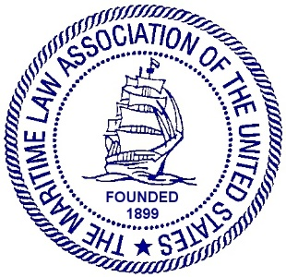
MARITIME LAW ASSOCIATION OF THE UNITED STATES
JOINT MEETING OF OUR OCEANS COMMITTEE AND
YOUNG LAWYERS COMMITTEE
MEETING AGENDA SPRING 2022
THURSDAY MAY 5, 2022, 1:30 – 3:30 pm
Clyde & Co.
The Chrysler Building, 21st Floor
405 Lexington Avenue
DRAFT AGENDA
- WELCOME:

- Introduction of Young Lawyer and Our Oceans Officers:

YLC:
Chair Peter F. Black
Vice Chair Kristi H. Thompson
Secretary Kenderick M. Jordan
BOD Liaison David J. Farrell, Jr.

Our Oceans:
Chair Christopher E. Carey
Vice Chair Sean Houseal
Secretary Eva-Maria Mayer
YLC Liaison George Croton
BOD Liaison Jennifer Porter

- Our Oceans Mission Statement:
The Our Oceans Committee monitors and reports on ocean resources and their economic, environmental, sustainable, and competing uses. We follow international and U.S. oceans policy developments in legal, scientific, and commercial spheres of interest to the MLA’s membership, including but not limited to: climate change, polar ice melt, increased Arctic access, and rising sea levels; and the impact of human actions on the oceans.

- SPEAKERS:
- Frederick Joseph Kenney, Jr.: (bio) Director of Legal and External Affairs at IMO with update on IMO Post-Glasgow 2021 Decarbonization Regulations and Enforcement Plans;

- TBD

- OUR OCEANS: Committee Business

- Situation Update

- Recent Developments (George Croton)
- YLC: Committee Business
- YLC Committee Liaison Program & Reports
  - Program Overview
  - Current Liaison Openings
  - Committee Liaison Reports
- Membership and Proctor Status
- Recent YLC Work and Recognition
- YLC Projects & New Business
- YLC Social Events & Social Media
- ADJOURNMENT

