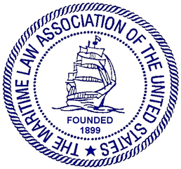

STEVEDORES, MARINE TERMINALS,
AND VESSEL SERVICES COMMITTEE

Thursday, May 5 2022, 10:30 – 12:00 p.m.
Clyde & Co.
The Chrysler Building, 16th Floor
405 Lexington Avenue, Class Room 1

AGENDA

I. Welcome and Speaker Introductions
Deborah C. Waters, Waters Law Firm, Norfolk, Virginia (10 Minutes)
10:30-10:40

II. Post-pandemic catch-up and plans for San Diego Fall Meeting
(20 Minutes) 10:40-11:00

III. Identification of Issues of Interest to Committee Members (20 minutes) 11:00-11:20
- Effects of offshore wind projects on stevedores, terminals tariffs, labor contracts, Jones Act compliance, etc.
- Input from Committee Members on issues of interest to be addressed in the future.

IV. Presentation on the Effects of the Ukraine/Russian Conflict on Terminal Operations and
Vessel Services. (30 minutes) 11:20-11:40
Michael J. Dehart, Freehill Hogan & Mahar LLP

V. Old Business

VI. New Business
Deborah C. Waters, Waters Law Firm, Norfolk, Virginia Status of ILA and ILWU
collective bargaining agreements negotiations. (5 minutes)

VII. Adjournment

