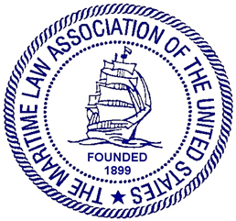

MARITIME LAW ASSOCIATION OF THE UNITED STATES

STEVEDORES, MARINE TERMINALS AND
VESSEL SERVICES COMMITTEE

Thursday, October 27, 2022
1:00 p.m. to 2:00 p.m. PDT
Spreckles Room, Hotel Del Coronado, San Diego, California

AGENDA

I. Welcome and Announcements
Deborah C. Waters, Chair, Waters Law Firm, Norfolk, Virginia
1:00 – 1:05

II. Ocean Shipping Reform Act Panel Discussion
David H. Sump, Moderator, Willcox & Savage, Norfolk, Virginia
Mark Newcomb, Zim American Shipping, Norfolk, Virginia
Eleanor Torres, Port of Long Beach, Long Beach, California
1:05 – 1:50

III. Old Business/New Business
1:50 – 2:00
- Where are we on labor contract negotiation?
- Formation of Committee to Report on Offshore Wind/Jones Act issues
- Announcement of Committee roundtable discussions and CLE by Zoom
  - John Bradley, Discussion of Current FMC Rulemaking
  - Report on Offshore Wind/Jones Act issues (potential CLE)

IV. Adjournment

