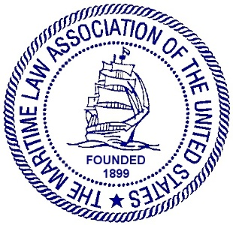
MARITIME LAW ASSOCIATION OF THE UNITED STATES
YOUNG LAWYERS COMMITTEE
MEETING AGENDA FALL 2023
THURSDAY OCTOBER 19th, 2023, 3:30 – 5:00 pm
Holland & Knight
560 Mission St., Suite 1900
San Francisco, CA
DRAFT AGENDA
- WELCOME
  - Introduction of Young Lawyer Officers:
Chair Kristi Thompson
Vice Chair Kenny Jordan
Secretary Caroline Wilson

- MEMBERSHIP REPORT:
  - Report on current YLC membership
  - Information on Proctor Status and application process
- OLD BUSINESS:

- LIAISON OPENINGS:
  - Program Overview
  - Current vacancies:
    - Salvage
    - Offshore Industries

- LIAISON REPORTS:
In order of committee meetings:

  - Autonomous Ships and Smart Marine Technology/Marine Torts and Casualties/Government Counsel

  - Marine Financing/Maritime Bankruptcy and Insolvency

  - Practice and Procedure/Marine Pollution and Maritime Crimes

  - Cruise Lines and Passenger Ships/Our Oceans/International Organizations, Conventions and Standards/Regulation of Vessel Operations, Safety, Security and Navigation

  - Stevedores, Marine Terminals, and Vessel Services

  - Law School Liaison

  - Cybersecurity

  - Fisheries

  - Recreational Boating/Offshore Industries

  - In-House Counsel

  - Uniformity of US Maritime Law

  - Salvage/Marine Insurance and General Average

- NEW BUSINESS:
  - Regional CLE Seminars
  - Planning for Spring Meeting 2024
- ADJOURNMENT:
We will meet for drinks directly after at Pagan Idol, 375 Bush St, San Francisco, CA.

