Maritime Law Association of the United States May 2024 Meetings – New York, New York
Committee on Inland Waters and Towing Meeting Agenda
Thursday May 2 at 1:30 p.m.-3:00 p.m. EST
Location: K&L Gates LLP, 599 Lexington Avenue, New York, NY (31-D)
- Welcome and Opening Remarks – David Boyajian, Schwabe Williamson & Wyatt, P.C., Portland, OR
- Presentation: What’s That Dredge Doing Here? Dredging Projects, Operations and Risk Management Fundamentals
A. Overview of Dredging Project Types
- Maintenance Projects
- New Work Projects
- Beach Nourishment Projects
- Sub-Sea Infrastructure Projects
B. Dredging Equipment Overview
- Hopper Dredging
- Cutter Dredging
- Bucket/Scow Dredging
- Key Support Equipment (Boosters, Support Boats, Land-Side)
C. Current U.S. Project landscape
- Ongoing Projects
- Future Projects
D. Operation and Commercial Risk Management
- Operational Risks (sub-sea obstructions, mechanical issues, traffic control)
- Contractual Issues
- Risk Management Issues
Speakers:
Chuck Broussard, Jr. – Dredging Division Manager, Weeks Marine, Inc.;
Brian Henninger – Assistant General Counsel, Weeks Marine, Inc.;
David Konz – Risk Manager, Weeks Marine, Inc.
- Good of the Order: “heads” up from the floor of topical issues and recent developments; suggestions for future topics; random thoughts or musings by participants; wrap up by David Boyajian and discussion about Committee leadership.
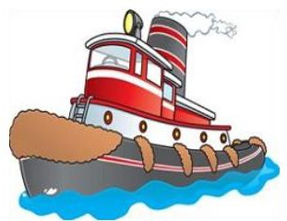
- Adjourn.

