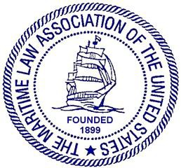

MARITIME LAW ASSOCIATION OF THE UNITED STATES

JOINT MEETING OF MLA COMMITTEES ON REGULATION OF VESSEL OPERATIONS, SAFETY, SECURITY AND NAVIGATION
&
MARINE POLLUTION & MARITIME CRIMES

Thursday, May 2, 2024
2:00 p.m. – 3:30 p.m. EDT

BLANKROME
1271 Avenue of the Americas | New York, NY 10020
Corner of 50th and 6th Avenue
(Midtown)

Rsvp: Alexandra.clark@blankrome.com; madison.hoehn@blankrome.com

AGENDA

- Welcome and Opening Remarks (Committee Chairs) (5 mins)
- Marine Pollution & Maritime Crimes. (30 mins)
  - “’Not One Word’: Why and How the U.S. Department of Justice is Hiding from Maritime Sex Crimes,” Ryan Melogy, Maritime Legal Solutions, PLLC

- Regulation of Vessel Operations, Safety, Security and Navigation. (update/speaker) (30 mins)
- Closing Remarks (5 min)

Committee on Regulation of Vessel Operations, Safety, Security and Navigation:

Steve Stancliff (sstancliff@ventkerlaw.com) Bill Bennett (wbennett@blankrome.com)
Committee on Government Counsel:  Jessica McClellan (jessica.l.mcclellan@usdoj.gov) Michael Dilauro (Michael.dilauro@usdoj.gov) | Marine Pollution and Maritime Crimes Committee:  Liam O’Connell (loconnell@fsofirm.com)  Jennifer Porter (jennifer.porter@thomasmiller.com)

