**LIEUTENANT COMMANDER TONI A. GOODIN**

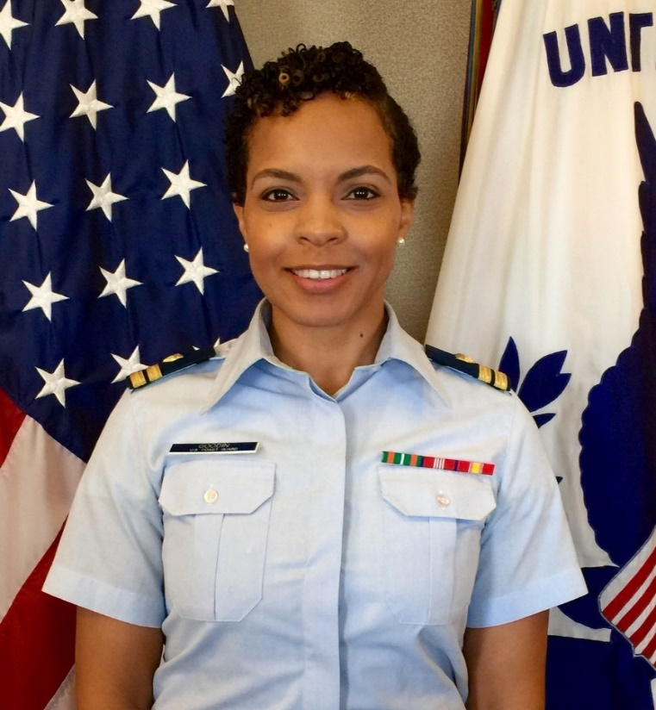LCDR Goodin currently serves as the embedded legal counsel for the Coast Guard Investigative Service (CGIS). She is responsible for providing legal advice to the CGIS Director, as well as to regional offices nationwide. She oversees the provision of legal services to over 400 active duty, reserve, and civilian federal criminal investigators and provides advice in support of missions worldwide. CGIS special agents exercise their law enforcement authorities to investigate federal crimes with a maritime nexus, military justice, and other offenses affecting USCG authorities.

Prior to reporting to CGIS, LCDR Goodin served as Special Assistant United States Attorney for Florida’s Middle District. She was responsible for federal investigation and prosecution of high volume international maritime narcotics smugglers in support of CG units patrolling the Eastern Pacific Ocean and Caribbean Sea. LCDR Goodin led multiple litigation teams in the successful prosecutions for trafficking multi-million dollar drug loads, spearheading strategic litigation plans to minimize operational impact to service members.

LCDR Goodin’s previous assignments include embedded trial counsel at the Navy Defense Service’s Office Southwest handling military justice cases, including a high visibility war crimes violations case, and a varied caseload representing service members in criminal and administrative matters. Balancing a portfolio of 150 clients from the Coast Guard, Navy, and Marines with a heavy travel schedule, her work ensured skillful representation of all clients. Prior to that she was Staff Attorney for the Coast Guard’s Fifth District legal office, managing all military justice matters, operational law, ethics, and general law. Prior to the Fifth District she was a Claims Attorney for the Legal Service Command-East in Norfolk, VA, adjudicating military and civilian federal torts claims against the Coast Guard, and a Student Legal Intern to Assistant Commandant for Intelligence (CG-2) declassifying military records and responding to Freedom of Information Act requests for two years during law school.

LCDR Goodin is a licensed to practice law by the State of New York.  She graduated in 2013 with a juris doctor from Howard University School of Law in Washington, DC, and earned a Bachelor of Arts in International Relations and National Security from the University of Virginia.