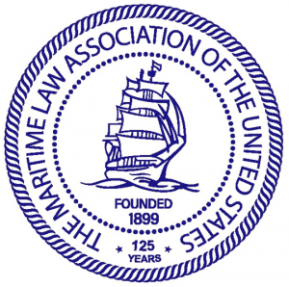

Perspectives on the MV Dali

On March 26, 2024, at approximately 1:29am EDT, the 947-foot-long Singapore-flagged cargo vessel Dali was transiting out of Baltimore Harbor in Baltimore, Maryland, when it experienced a loss of electrical power and propulsion and struck the southern pier supporting the central truss spans of the Francis Scott Key Bridge, causing a partial collapse of the bridge into the Patapsco River.
The National Transportation Safety Board’s Marine Investigation Preliminary Report (the “Preliminary Report”) details the events of that fateful night leading up to the major maritime casualty. The following is a timeline of events, taken from the Preliminary Report.
12:05am – A senior pilot and apprentice pilot boarded the Dali at Seagirt Marine Terminal. During the exchange, the pilot asked about the vessel’s condition to which the captain replied the ship was in good working order.
12:36am – Two tugboats pulled the Dali away from the dock.
12:45am – The senior pilot ordered the main propulsion engine to “dead slow ahead”.
1:07am – The vessel entered the Fort McHenry Channel and the senior pilot gave orders for the tugs to be let go.
1:09am – The main engine’s speed was increased to “slow ahead” and the apprentice pilot ordered a course to transit under the Key Bridge.
1:25am – Electrical breakers that fed most of the vessel’s equipment and lighting tripped and caused a loss of electrical power to most bridge equipment and the main engine cooling water pumps and steering gear pumps when the Dali was .6 miles from the Key Bridge.
1:26am – The senior pilot regained control from the apprentice pilot and called for tug assist.
1:27am – The senior pilot ordered an anchor dropped and the crew began the process to drop anchor. The pilot’s dispatcher notified the Coast Guard and called the Maryland state police to relay the ship had lost power.
1:29am – The Dali’s starboard bow struck piers no. 17 of the Key Bridge at 6.5 knots and six spans of the bridge collapsed into the water and across the ship’s bow.
Six members of a road maintenance crew working on the bridge were killed, one maintenance worker was seriously injured, and one member of the Dali’s crew suffered more minor injuries.
The preliminary report indicates an electrical failure caused the ship to lose power to the main engine. The day before the accident, the Dali experienced two blackouts while at berth, which prompted the crew to switch the main electrical bus configuration, however the investigation is on-going and probable cause has not yet been determined.
As facts continue to come to light, the legal battle over damages and who is liable to pay has already started. On April 1, the Singaporean shipowner and shipmanager Synergy Group filed a “Petition for Exoneration from or Limitation or Liability” seeking to limit their liability to $42.5M. The City of Baltimore then filed a lawsuit against the shipowner and manager, alleging negligence in allowing the Dali to leave the port in an unseaworthy condition. The complaint cites 23 separate acts or omissions of the shipowner and manager, and estimates the total damages well above the $43M the shipowner and manager say represents the value of the vessel and pending freight at the time of the accident. The Federal Bureau of Investigation (FBI) has also launched its own criminal inquiry into the accident.
These claims and the others that may arise will likely take years to resolve. In this CLE, we will attempt to cover just a few of the legal issues and challenges that arise in any major maritime casualty, and how they may play out in the case of the MV Dali.

Maritime Law: Vessel Owner's Privity and Knowledge in the Context of the Francis Scott Key Bridge Incident
Generally, as stipulated in 46 U.S.C. § 30505(b), a vessel owner cannot limit liability if an incident occurs with their "privity or knowledge." Fundamentally, while every owner is responsible for their own negligence, they may be able to limit liability for negligence by their non-management employees. As interpreted in Cape Fear Inc. v. Martin, 312 F.3d 496, 2002 AMC 2733 (1st Cir. 2002), the rule is as follows: "the liability [of the owner] may be limited to the value of the ship and its freight if the owner can demonstrate lack of both awareness of the unseaworthy condition and privity with anyone who did have knowledge." The critical issue regarding employees' negligence or knowledge is whether the vessel owner is "in privity" with such employees. See also In re Western Pioneer Inc., 2002 AMC 1743 (W.D. Wa. 2002), where the court found no privity in a vessel master's "spontaneous negligent navigational error" leading to a collision, because the master was properly licensed, trained, instructed, adequately familiar with the vessel, and had a good safety record. Knowledge of the master of a "seagoing vessel" before the voyage will be attributed to the owner concerning personal injury or death. There is a circuit conflict as to the definition of "seagoing vessel" (discussed later).

What is "privity and knowledge"?
(a) Definitions: "Privity" under the Act has been defined as:
... personal participation of the owner in some fault, or act or act of negligence, causing or contributing to the loss, or some personal knowledge or means of knowledge, of which he is bound to avail himself or a contemplated loss, or a condition of things likely to produce or contribute to the loss, without adopting appropriate means to prevent it.
Lord v. Goodall Nelson & Perkins S.S. Co., 102 U.S. 541 (1877); See also Petition of M/V Sunshine II, 808 F.2d 762 (11th Cir. 1987). Coryell v. Phipps, 317 U.S. 406, 1943 AMC 18 (1943) stated that consistent with the statutory purpose of the Limitation of Liability Act to protect "innocent investors," privity or knowledge generally refers to the vessel owner's personal involvement in or actual knowledge of the specific acts of negligence or conditions of unseaworthiness that caused or contributed to the incident. Nuceio v. Royal Indemn. Co., 415 F.2d 228, 1969 AMC 1825, 1827 (5th Cir. 1969) defines "privity and knowledge" as "complicity in the fault that caused the accident." See also Cupit v. McClanahan Contractors Inc., 1 F.3d 346, 1994 AMC 784 (5th Cir. 1983).
"Knowledge" means the personal awareness of which the owner must avail itself. Hernandez v. M/V Rajuan, 841 F.2d 582, 1989 AMC 521 (5th Cir. 1988). A high level of diligence is required of an owner to detect and correct faults: "The measure in such cases is not what the owner knows but what he is obligated to find out." In re Sause Bros. Ocean Towing Co., 769 F.Supp 1147 (D. Or. 1991) quoting States S.S. Co. v. United States, 259 F.2d 458, 466, 1957 AMC 1181 (9th Cir. 1957) and Great Atlantic & Pacific Tea Co. v. Brasileiro, 159 F.2d 661, 1947 AMC 306, 312 (2nd Cir. 1947). Constructive knowledge exists where the owner should have obtained the necessary information through reasonable inquiry. Complaint of Patton-Tully Transp. Co., 797 F.2d 206 (5th Cir. 1986). Parks' "THE LAW OF TUG, TOW & PILOTAGE," 2nd Ed. at pp. 352-355, summarizes relevant cases.
Many maritime practitioners understand the current climate of limitation to mean that courts will attribute personal negligence or privity and knowledge if an owner has even a hint of a condition or potential problem that resulted in a loss. Zeringue v. Gulf Fleet Marine Corp., 666 F.Supp. 860, 1988 AMC 1694 (E.D. La. 1987) delved into this issue, finding that "privity" is fault or neglect in which the shipowner personally participates, and "knowledge" is the means of personal awareness that a shipowner is legally bound to pursue regarding a condition likely to cause the loss. As technology and industry advance, more "proper means" of prevention become available and should be adopted by a reasonable vessel owner.
(b) Judicial Trends: During the 1980s-1990s, the Amoco Cadiz Limitation Proceedings, 1992 AMC 914 (7th Cir. 1992) noted:
The recent judicial trend has been to enlarge the scope of activities within the “privity or knowledge” of the shipowner, including to corporations' knowledge or privity of lower-level employees…; requiring shipowners to exercise an ever-increasing degree of supervision and inspection …; imposing a heavy burden on shipowners to prove their lack of privity or knowledge; rendering the shipowner’s duty to ensure the seaworthiness of the ship nondelegable; and narrowing the group of potential defendants eligible for exoneration under the Act … .
(c) The 2000s and Beyond
But things have changed even further since 2000. In practice, to what extent do corporate owners control a vessel while at sea (and, for that matter, the master)? In the Navy, we jokingly refer to technology and its grant of Admiral-reach-down capability as the “35,000-foot screwdriver.” How does that concept line up in the commercial world? Does the law incentivize or disincentivize best practices?
Some Common-ish Examples
Isolated Errors in Navigation by Vessel Crew: In In re Omega Protein Inc. v. Samson Contour Energy E & P, LLC, 548 F.3d 361 (5th Cir. 2008), the court held that isolated errors in navigation (without a pattern of improper or unsafe behavior) by the master and crew are not attributed to the owner. Similarly, Brister v. A.W.I. Inc., 946 F.2d 350, 1993 AMC 1990 (5th Cir. 1991), supported this view. However, despite the limitation plaintiff's argument that a grounding resulted from a "spontaneous error" by a passenger ferry master, the court in In re Bald Head Island Transp., 2015 AMC 2339 (E.D. N.C. 2015), granted summary judgment by finding privity and knowledge of the demise charterer, citing prior known and ongoing issues with the master’s navigational awareness.
General Navigational Negligence by the Crew: Generally, the crew's negligent acts or navigational errors are not attributed to the owner for determining privity and knowledge. This principle was upheld in Hellenic Lines Ltd. v. Prudential Lines Inc., 730 F.2d 159, 1984 AMC 57 (3rd Cir. 1984). In Re Kristie Leigh Ent. Inc., 72 F.3d 479, 1996 AMC 697 (5th Cir. 1996), it was decided that navigational errors by a master are not imputed to an owner if the owner selected a competent master and had no actual notice of a pattern of navigational errors. Kristie Leigh appears to permit "hands-off" corporate management if the vessel's master is competent and adequately trained and the errors are confined to navigation. Trico Marine Assets Inc. v. Diamond B Marine Services Inc., 332 F.3d 779, 2003 AMC 1355 (5th Cir. 2003), echoed similar sentiments. Additionally, In re American Milling Co., Ltd., 409 F.3d 1005, 270 F.Supp.2d 1068, 2005 AMC 1217 (8th Cir. 2003), and State of Washington v. Sea Coast Towing Inc., 2005 AMC 572, 579 (W.D. Wa. 2004), reiterated that negligent navigational errors by a master or crewmember, causing a collision or allision, do not establish privity or knowledge for the vessel owner.
Officer Compliance with Navigation Rules: In In re Otal Investments Ltd., 673 F.3d 108, 2012 AMC 913 (2nd Cir. 2012), the court reversed a trial court’s finding that a vessel owner had constructive knowledge of a master’s practice of not constantly posting lookouts at night, relying on overtime records. The Second Circuit deemed the overtime logs insufficient evidence of the owner’s knowledge. The trial court, on remand, found that management knew or should have known of the master’s consistent understaffing of watches and imposed a duty on management to supervise and inspect practices.
Contractor Negligence: In Gibboney v. Wright, 517 F.2d 1054, 1975 AMC 2071 (5th Cir. 1975), the court refused to impute privity and knowledge relevant to the negligence of a vessel builder or a surveyor hired by the owner.
Safety Plans and Procedures: In In re Moran Towing Corp., 984 F. Supp.2d 150 (S.D. N.Y. 2013), the court found that failure to conduct a job hazard analysis and develop adequate safety plans and procedures for operating a winch was within the privity and knowledge of management. This case is often interpreted as showing how the relative level of risk influences when a company “should” know something.
Knowledge of Prior Reckless Acts by Operator: In Dieber Limitation Proceedings, 793 F.Supp.2d 632, 2012 AMC 198 (S.D. N.Y. 2011), the court found privity and knowledge regarding negligent or reckless operation of a high-performance powerboat because the owner knew his son often consumed alcohol and recklessly operated the vessel.
Operation of Vessel without Owner’s Permission: In Clementi v. Commercial Union Ins. Group, 92 Fed. Appx. 826 (2nd Cir. 2004), the court affirmed judgment exonerating the owner of a vessel stolen by a group of "young people" (including the owner’s nephew). The group snuck aboard, threw a party without permission, found an ignition key, and took the vessel for a joyride.
Procedures for Adverse Weather Conditions: In Furka v. Great Lakes Dredge & Dock Co., 1984 AMC 349 (D. Md. 1983), the court found privity and knowledge of the owner for failing to establish and implement procedures for shutting down operations during adverse weather. Similarly, Brunet v. United Gas Pipeline Co., 15 F.3d 500, 1994 AMC 1565 (5th Cir. 1994) found privity and knowledge when management knew the vessel operated in high winds and occasionally became "windbound." Other similar cases include Spencer Kellogg & Sons Inc. v. Hicks, 285 U.S. 502, 1932 AMC 503 (1932); Hogge v. S.S. Yorkmar, 434 F.Supp. 715, 1977 AMC 805 (D. Md. 1977); and Pennzoil Producing Co. v. Offshore Express Inc., 943 F.2d 1465, 1994 AMC 1034 (5th Cir. 1991), which found privity and knowledge of a corporate officer relative to a collision in fog when the officer knew the company’s vessels operated in fog and sometimes fog operations resulted in accidents.
Navigational Equipment and Charts: Matter of Texaco Inc., 570 F.Supp. 1272, 1985 AMC 1650 (E.D. La. 1983), found privity and knowledge when the owner failed to provide the vessel with accurate charts and appropriate navigational equipment. TT Boat Corp. Limitation Proceedings, 1999 AMC 2776 (E.D. La. 1999), found privity and knowledge of a tug operator for failing to implement a system to ensure updated charts were on board. In re Complaint of Thebes Shipping Inc., 486 F.Supp. 436 (S.D. N.Y. 1980), reached a similar conclusion when a vessel grounded due to improperly scaled and outdated charts and a gyro compass malfunctioning for several voyages.
Negligent Policy Enforcement: The Linseed King, 285 U.S. 502, 1932 AMC 503 (1932), and In re City of New York, 522 F.3d 279, 2008 AMC 1389 (2nd Cir. 2008), are precedents that found privity and knowledge of corporate officers for failing to enforce otherwise adequate policies. Kellogg involved the failure to enforce a policy regarding operating vessels in icy conditions. City of New York involved failure to enforce a "two pilot" policy requiring two officers on the bridge while underway.
Supervision and Instruction: In Farrell Lines Inc. v. Jones, 530 F.2d 7, 1976 AMC 1639 (5th Cir. 1976), the court reversed a trial court’s denial of limitation and finding that the company should have established procedures to ensure a second officer monitored a watch officer who monitored that the helmsman properly interpreted helm orders. In re Moran Towing Corp., 984 F. Supp.2d 150 (S.D.N.Y. 2013), aff’d in part and vac in part 996 F.Supp.2d 221 (S.D.N.Y. 2015), found that management’s failure to adequately train or supervise its crew in safely performing a dangerous task defeated the right to limit liability. The Linseed King, 285 U.S. 502, 1932 AMC 503 (1932), required that the owner establish a system to ensure compliance with policies against operating vessels in ice by follow-up with inquiries or personal inspections. States S.S. Co. v. United States, 259 F.2d 470, 1958 AMC 1775 (9th Cir. 1958), followed Spencer & Kellogg, holding that a vessel owner must ensure the vessel’s seaworthiness. In re Ocean Foods Boat Co., 692 F.Supp. 1253 (D. Or. 1988), followed Kellogg, finding that an owner must exercise reasonable diligence to ensure the master operates the vessel according to instructions. In re S.D.S. Lumber Co. v. Tug Bruce M, 567 F.Supp.2d 1302, 2009 AMC 1899 (D. Or. 2008), found privity and knowledge of the owner for failure to investigate a prior casualty and develop standards for safe navigation.
Officer Training: In re Amoco Cadiz, 1984 AMC 2123 (N.D. Ill. 1984), aff’d, 1992 AMC 913 (7th Cir. 1992), found culpability of the vessel owner for failing to educate its master about his authority to order salvage services before a casualty developed. Hercules Carriers Inc. v. State of Florida, 768 F.2d 1558 (11th Cir. 1985), found the vessel unseaworthy due to poor officer training, including not intervening or relieving a compulsory pilot, not posting lookouts, and not investigating officers’ fraudulent licenses. In re Potomac Transport Inc., 909 F.2d 42, 1991 AMC 190 (2nd Cir. 1990), it was held that a master’s failure to supervise the watchstanding of a newly licensed third mate breached the owner’s duty to exercise diligence in selecting, training, and supervising the vessel’s crew. Warrior & Gulf Nav. Co. Limitation Proceedings, 1997 AMC 1432 (S.D. Ala. 1996), found privity and knowledge when no meaningful training program existed for tug officers. Lockheed Martin Corp. v. Unknown Vessel, 2007 AMC 1338 (N.D. N.Y. 2007), found that management knew of the lack of training and supervision for a vessel operator and could not limit liability.
Competent Crew: The owner has a non-delegable duty to provide an adequate and competent crew for the intended voyage. The Ocean Prince v. United States, 584 F.2d 1151 (2nd Cir. 1976) ; Empire Seafoods Inc. v. Anderson, 398 F.2d 204, 1968 AMC 2264 (5th Cir. 1968); Admiral Towing Co. v. Wollen, 290 F.2d 641, 1961 AMC 2333 (9th Cir. 1961). Privity and knowledge are found even when crew hiring is delegated to the master. In re Ocean Foods Boat Co., 692 F.Supp. 1253, 1989 AMC 579 (D. Or. 1988). The issue is whether a loss resulted from mere negligence of officers and crew, in which case the owner may limit liability, or from incompetence, which bars the right to limit. In re Hellenic Cruises Ltd., 813 F.2d 634, 1987 AMC 2470 (4th Cir. 1987). Matter of Ta Chi Nav. Corp. S/A, 513 F.Supp. 148, 1982 AMC 1710 (E.D. La. 1981), rev’d, 691 F.2d 873, denied limitation on the ground that the master’s errors were so gross they amounted to incompetence. The burden is on the owner to establish crew competence or that incompetence did not cause the loss. See also Complaint of Seiriki Kisen Daisha, 629 F.Supp. 1374, 1986 AMC 913 (S.D.N.Y. 1986). In re Potomac Transport Inc., 909 F.2d 42, 1991 AMC 190 (2nd Cir. 1990), held that gross negligence of watch officers may raise a presumption of incompetence, rebuttable by showing due diligence in crew selection and training. Knowledge of the temporary incompetency of crewmembers, along with the time and opportunity for the owner to provide relief, defeats limitations. Complaint of Armatur, 710 F.Supp. 390, 1990 AMC 557 (D.P.R. 1989), found privity and knowledge where the owner knew the master had a "grinding work schedule," contributing to a grounding caused by exhaustion. Warrior & Gulf Nav. Co. Limitation Proceedings, 1997 AMC 1432 (S.D. Ala. 1996), found privity and knowledge of a tug owner for hiring an incompetent pilot with a history of seven reportable accidents knowable upon reasonable inquiry.
Negligent Entrustment: Favorito v. Pannell, 27 F.3d 716, 1994 AMC 2320 (1st Cir. 1994), states “the owner may be held liable for entrusting [the] vehicle to an incompetent, reckless, or unfit driver if the owner knew or should have known of the driver's incompetence, inexperience, or recklessness.” Joyce v. Joyce, 975 F.2d 379 (7th Cir. 1992), affirmed the dismissal of a limitation complaint concerning an injured passenger who claimed “negligent entrustment” to an operator without sufficient skill and experience. The court reasoned that if the owner was not in privity with the operator’s negligence, the underlying suit could not succeed. However, if the owner had sufficient knowledge of the operator’s incompetence to support negligent entrustment, that knowledge would defeat limitation. In re Cedar Bay Boat Rentals LLC, 2012 U.S. Dist. Lexis 109635, 2012 WL 3230982 (M.D. Fla. 2012), held that Joyce should be restricted to claims against individual owners and not applied to corporate or LLC owners. In re Complaint of Messina, 574 F.3d 119 (2nd Cir. 2009), found privity and knowledge of a personal watercraft owner who believed the operator was competent but had no objective facts to support that belief. See also In Re Complaint of Royal Caribbean, 2013 AMC 708 (S.D. Fla. 2013). Pace v. Davis, 161 Wn. App. 1032 (2011), addressed negligent entrustment, affirming denial of liability for an owner who instructed others not to use the watercraft that day, emphasizing the necessity of consent to relinquish control.
Fatigue of Crewmembers: State of Washington v. Sea Coast Towing Inc., 2005 AMC 572 (W.D. Wa. 2004), held that the owner misinterpreted Coast Guard rest regulations and failed to ensure compliance with the 12-hour work limitation but found insufficient proof that a tug master who fell asleep at the wheel violated the regulation in the 48 hours before an allision with a bridge.
FSK Relevant Points of Interest:
Maintenance and Repair Procedures: In re Amoco Cadiz, 1984 AMC 2123 (N.D. Ill. 1984), aff’d, 1992 AMC 913 (7th Cir. 1992), the court found privity and knowledge when the owners failed to establish and implement adequate maintenance and repair procedures to ensure the vessel’s equipment was in good operating condition.
Effect of Owner’s Instructions to Remedy Known Conditions: States S.S. Co. v. United States, 259 F.2d 458, 472 (9th Cir. 1957), stated: “[W]here circumstances require owners or managing agents to act to make the vessel seaworthy, failure to take such action will result in denial of limitation. Mere instructions to subordinates are insufficient.” See also Leo LLC v. Flora, 2012 AMC 471 (W.D. Wa. 2011).
Errors by Compulsory Pilots: Mo Barge Lines Inc. Limitation Proceedings, 2004 AMC 693 (8th Cir. 2004) clarified that no privity is attributed to the owner for a vessel’s pilot where hiring the pilot was not negligent and there was no equipment failure or breach of the owner’s duty of instruction.

Privity and Knowledge of Corporate Management (An anachronism?)
Courts apply different standards for imputing the negligence of subordinate employees to individual or partnership owners compared to corporate owners. Coryell v. Phipps, 317 U.S. 406, 1943 AMC 18 (1943); Gibboney v. Wright, 517 F.2d 1054, 1975 AMC 2071 (5th Cir. 1975). Employees' negligence is generally imputed to the owner when the owner is an individual or a partnership. For corporate shipowners, liability is not limited “where the negligence is that of an executive officer, manager, or superintendent whose authority included supervision over the phase of the business from which the injury arose.” Coryell, 317 U.S. at 410-1. Accordingly, “knowledge is judged by what the corporation's managing agents knew or should have known about conditions likely to cause the loss.” In re Hellenic Inc., 252 F.3d 391, 394, 2001 AMC 1835 (5th Cir. 2001) (citation omitted); see also Craig v. Continental Ins. Co., 141 U.S. 638, 646 (1891) (“When the owner is a corporation, the privity or knowledge must be that of the managing officers.”); Carr v. PMS Fishing Corp., 191 F.3d 1, 4 (1st Cir. 1999) (“When a corporation owns the vessel, the test is whether culpable participation or neglect of duty can be attributed to an officer, managing agent, supervisor, or other high-level employee of the corporation.”) The scope of an employee's responsibilities, not their title, determines whether limitation of liability is appropriate. Continental Oil v. Bonanza Corp., 706 F.2d 1365, 1377 n. 16, 1983 AMC 2059 (5th Cir. 1983) (“Whether a corporation has ‘privity or knowledge’ of a negligent act may be determined by whether the negligent employee is sufficiently high in the corporate hierarchy to make their awareness that of the corporation.”)
For corporate shipowners, the privity and knowledge of “corporate managers vested with discretionary authority” is attributed to the corporation. Great Lakes Dredge & Dock Co. v. City of Chicago, 3 F.3d 225, 231, 1993 AMC 2409, 2419 (7th Cir. 1993), aff’d sub nom Jerome B. Grubart Inc. v. Great Lakes Dredge & Dock Co., 513 U.S. 527, 1995 AMC 913 (1995), distinguished “managerial” employees from “purely ministerial” employees for purposes of determining corporate privity or knowledge. If the president of a corporation personally participates in the control and operation of the vessel, privity and knowledge are attributed to the corporation. In re Complaint of Marine Sports Inc., 840 F.Supp. 46, 1994 AMC 1678 (D. Md. 1993). Courts impute privity and knowledge to the corporation if the culpable employee is an executive officer, manager, or superintendent whose scope of authority includes supervision over the phase of the business from which the loss or injury arose. Coryell; In Re Hellenic Lines Ltd., 813 F.2d 634, 1987 AMC 2470 (4th Cir. 1987); Union Oil Co. v. M/V Point Dover, 756 F.2d 1223 (5th Cir. 1985); Zeringue v. Gulf Fleet Marine Corp., 666 F.Supp. 860, 1988 AMC 1694 (E.D. La. 1986). In contrast, In re Complaint of Leader Marine Co. S.A., 1982 AMC 2068 (N.D. Cal. 1981), denied limitation when the vessel sank because port staff failed to inspect and maintain the piping system and were aware the engineers did not have the piping system drawings.
Knowledge of the master may be imputed to a corporate owner where the master is a corporate officer and/or has management responsibility. In Continental Oil Co. v. Bonanza Corp., 706 F.2d 1365, 1983 AMC 1059 (5th Cir. 1983), where the master exerted “almost exclusive control” over the vessel’s business activities, the court considered the master a “managing agent” whose privity and knowledge were imputable to the corporate owner, precluding it from limiting liability for negligent navigation. See also In re Mellon Transp. Co. Inc., 1974 AMC 1293 (N.D. W. Va. 1974); Bates v. Merritt Seafood Inc., 663 F.Supp. 915, 1989 AMC 81 (D. S.C. 1989). Cupit v. McClanahan Contractors Inc., 1 F.3d 346, 1994 AMC 784 (5th Cir. 1983), narrowed the definition of “management” to those with authority relative to the field of operation in which the negligence occurred. In re Hellenic Inc. held that a construction superintendent who decided the moorage of an unmanned construction barge was not sufficiently high on the managerial scale to impute his fault to corporate management. Trico Marine Assets Inc. v. Diamond B Marine Services Inc., 332 F.3d 779, 2003 AMC 1355 (5th Cir. 2003), held that corporate management participated in the negligence of a vessel involved in a collision, failing to evaluate the vessel’s seaworthiness, train the master in radar use, employ a safety manager, provide safety training and manuals, and employ a properly qualified master despite knowing the vessel operated in fog.
In re Vulcan Materials Co., 379 F.Supp.2d 737 (E.D. Va. 2005), discussed when an employee’s standing in the corporate structure justifies imputing privity or knowledge of an unseaworthy condition. Vulcan explained a two-part test: (1) consideration of the employee’s supervisory authority relative to where the negligence occurred, and (2) whether the employee’s position justified corporate liability for his knowledge. Lockheed Martin Corp. v. Unknown Respondents, 2007 AMC 1338 (N.D. N.Y. 2007), found privity of corporate management in failing to ensure that a launch boat master was competent and properly trained. In Re BOPCO L.P., 2013 U.S. Dist. Lexis 128991 (E.D. La. 2013), found privity and knowledge of corporate management in failing to adequately train an uninspected vessel master lacking thorough knowledge of the rules of the road and in having a policy against using radar in clear weather.

Privity and Knowledge of Individual Owner: The "Owner at the Helm" Rule (For the Little Guys)
An individual vessel owner cannot limit liability if they personally participated in the vessel's maintenance, control, and operation, as any fault would be directly attributed to them. Fecht v. Makowski, 406 F.2d 721, 1969 AMC 144 (5th Cir. 1969); In re Marine Sports Inc., 840 F.Supp. 46, 1994 AMC 1678 (D. Md. 1993); In re Complaint of Ingoglia, 723 F.Supp. 512, 1990 AMC 357 (C.D. Cal. 1990). Keller v. Jennette, 940 F.Supp. 35, 1997 AMC 955 (D. Me. 1996), held that there must be some personal fault or negligence on the owner's part, or concurrence with the fault of another, to deny the right to limit. The owner's presence on the vessel or at the helm does not alone establish their privity and knowledge. See also Estate of Muer v. Karbel, 146 F.3d 410, 1998 AMC 2668 (6th Cir. 1998); Suzuki of Orange Park Inc. v. Schubert, 86 F.3d 1060, 1997 AMC 457 (11th Cir. 1996); In re M/V Sunshine II, 808 F.2d 762 (11th Cir. 1987). In Re Hohnechi, 2013 U.S. Dist. Lexis 133790, 2013 WL 5220799 (D.C. Ariz. 2013), held that because the limitation plaintiff acknowledged operating the vessel during the collision, if there was negligence on his part, he could not claim lack of privity and knowledge. See also Broadwater v. Duplantier, 2013 U.S. Dist. Lexis 161819, 2013 WL 6000580 (E.D. La. 2013). In re Deng, 2014 AMC 1295 (N.D. Cal. 2014), denied a summary judgment motion regarding an owner's privity when operating his vessel at the time of capsize: a limitation plaintiff is entitled to present facts showing prudent conduct. In re Complaint of Tourtellotte, 2010 U.S. Dist. Lexis 130209, 2010 WL 5140000 (D. N.J. 2010), indicated that the "owner at the helm" rule would not bar limitation when the complaint alleged mechanical failure not necessarily due to owner neglect but dismissed the limitation claim due to lack of evidence that the operator was an owner pro hac vice. Goodman v. Williams, 287 F.Supp.2d 160, 2003 AMC 353 (D. N.H. 2003), denied a motion to dismiss a limitation action when the owner/operator alleged the cause of injuries was unknown. The court held that since it could not determine on the motion that the petitioner was negligent, the motion to dismiss the limitation claim should be denied. See also In re Complaint of Livolsi, 2005 AMC 1070 (D. Conn. 2005) and In re Matter of Arntz, 380 F.Supp.2d 1156 (C.D. Cal. 2005) (discusses the "owner at the helm" rule, which applies only when negligence is the owner's and not other crewmembers'). Via Sales & Leasing Inc. Limitation Proceedings, 499 F.Supp.2d 887, 2008 AMC 438 (E.D. Mich. 2007), states the "owner at the helm" rule is a "useful tool" but not a "talisman."

Burden of Proof of Privity or Knowledge
In a traditional 46 U.S.C. § 30511 proceeding under the Limitation of Liability Act, the claimant must prove the owner’s negligence or other liability. If liability is found, the owner must prove a lack of privity or knowledge of the relevant condition or negligence. Otal Investments Ltd. v. M/V Clary, 673 F.3d 108, 2012 AMC 913 (2nd Cir. 2012); Treanor Limitation Process, 2015 AMC 2857 (E.D. N.Y. 2015); In re Moran Towing Corp., 166 F.Supp.2d 773, 2002 AMC 103 (E.D. N.Y. 2001). Once the claimant shows that a fault attributable to the vessel seeking limitation was a proximate cause of the loss, the owner must prove it was without privity or knowledge of the condition or negligence. Coryell v. Phipps, 317 U.S. 406, 1943 AMC 18 (1943); Hernandez v. M/V Rajaan, 841 F.2d 582, 1989 AMC 524 (5th Cir. 1988); Self v. Great Lakes Dredge & Dock Co., 832 F.2d 1540, 1988 AMC 2278 (11th Cir. 1987); In re Hellenic Cruises Ltd., 813 F.2d 634, 1987 AMC 2470 (4th Cir. 1987); Oliver J. Olson & Co. v. Luckenbach S.S. Co., 279 F.2d 662, 1960 AMC 1230 (9th Cir. 1960); The 84-H, 296 Fed. 427 (2nd Cir. 1923); Treanor; Brown v. Teresa Marine IV Inc., 2007 AMC 954 (D. Me. 2007); Complaint of Cameron Boat Rentals Inc., 683 F.Supp. 577 (W.D. La. 1988). The shipowner need not prove the specific cause of the loss (and consequently lack of privity or knowledge of that cause):
If the basis for liability is a general condition, such as a finding of “unseaworthiness” of the vessel, the specificity of the claimant’s proof of liability determines the level of specificity at which the shipowner must prove lack of privity and knowledge.
Carr v. PMS Fishing Corp., 1 F.3d 1, 1999 AMC 2958 (1st Cir. 1999). When the right to limit is asserted as an affirmative defense, the owner-defendant may be required to “show how the loss occurred together with its lack of privity or knowledge of the asserted cause.” Terracciano v. McAlinden Const. Co., 485 F.2d 304, 307-08, 1973 AMC 2111 (2nd Cir. 1973); In re Moran Towing Corp.
The Other Maritime Context for Privity and Knowledge: Unseaworthiness
Unseaworthy Condition of Vessel: An owner has privity in an unseaworthy condition relevant to limiting liability “if they personally participated in the negligent conduct or caused the unseaworthy condition.” In re Omega Protein Inc. v. Samson Contour Energy E & P LLC, 548 F.3d 361 (5th Cir. 2008). See also Trico Marine Assets Inc. v. Diamond B Marine Services Inc., 332 F.3d 779, 2003 AMC 1355 (5th Cir. 2003); Pennzoil Producing Co. v. Offshore Express Inc., 943 F.2d 1465, 1994 AMC 1034 (5th Cir. 1991).
Does the Absolute nature of Unseaworthiness stick to Limitation Privity?
Multiple cases from the Eleventh Circuit held that knowledge of any unseaworthy condition is imputed to the owner if it existed at the voyage’s start. Villers Seafood Co. Inc. v. Vest, 813 F.2d 339, 1987 AMC 850 (11th Cir. 1987); Hercules Carriers Inc. v. Florida, 768 F.2d 1558 (11th Cir. 1985). Villers does not require a failure to exercise "due diligence" or actual knowledge by the owner's officers of the unseaworthy condition to deny the right to limit. Matter of Hechinger, 890 F.2d 202 (9th Cir. 1989), suggested in obiter dictum that since unseaworthiness liability is "absolute," there is no right to limitation if unseaworthiness caused the injury. In re Nicholls, 2012 AMC 1770 (S.D. Tex. 2012), states: “A shipowner has an ‘absolute non-delegable duty to provide a seaworthy vessel’ and ‘unseaworthiness is predicated without regard to fault or the use of due care.’ In re Signal Int’l. LLC, 579 F.3d 478, 497, 2009 AMC 2177 (5th Cir. 2009).” Dieber Limitation Proceedings, 793 F.Supp.2d 632, 2012 AMC 198 (S.D. N.Y. 2011), states “[a] shipowner has an absolute and non-delegable duty to provide a seaworthy vessel” under all circumstances. Although Signal Int’l recognizes unseaworthiness as strict liability, it holds that a vessel owner may limit liability if it proves a lack of privity and knowledge regarding the condition: “Signal's burden to prove lack of privity or knowledge arises only when MDOT has shown unseaworthiness was the proximate cause of the loss.” See In re Omega Protein, 548 F.3d at 371 (“[I]f the vessel's negligence or unseaworthiness is the proximate cause of the claimant's loss, the plaintiff-in-limitation must prove it had no privity or knowledge of the unseaworthy conditions or negligent acts.”). See also In re Bell, 2014 AMC 524 (W.D. Wa. 2014); In re Pellegrin Adams & Chauvin Towing Co., 2013 U.S. Dist. Lexis 37800, 2013 WL 1155064 (E.D. La. 2013); In Re Complaint of Royal Caribbean, 2013 AMC 708 (S.D. Fla. 2013), for the rule that proof of either negligence of a crewmember or other employee or unseaworthiness of the vessel causing the casualty shifts the burden of proof in a limitation of liability action to the vessel owner to prove its lack of privity and knowledge through actual or constructive knowledge regarding the unseaworthy condition. Leo LLC v. Flora, 2012 AMC 471 (W.D. Wa. 2011), stated that a shipowner could not limit its liability if the ship is unseaworthy due to equipment defective at the voyage’s start but did not rely on this rule, finding that the vessel manager had actual knowledge of the unseaworthy condition. Keys Jet Ski Inc. v. Kays, 893 F.2d 1225 (11th Cir. 1990), states that proof of unseaworthiness does not automatically defeat limitation but shifts the burden to the vessel owner to prove lack of privity and knowledge.

But is the Vessel even Seagoing?
In 1936, as codified in 46 U.S.C. § 30506(e), Congress made owners of "seagoing vessels" accountable for matters within the privity and knowledge of the masters "at or before the beginning of each voyage" regarding loss of life or bodily injury. In Moore-McCormack Lines, Inc. v. Steel Corp., 272 F.2d 833 (2nd Cir. 1959), the court held that the master's knowledge barred limitation concerning personal injury claims but not property damage claims. Matter of Hechinger, 890 F.2d 202 (9th Cir. 1989), broadly stated that the privity and knowledge of the master before the commencement of the voyage concerning an unseaworthy condition of the vessel will be imputed to the owner. This statement is unequivocally accurate regarding a "seagoing" vessel and relative to personal injury or death. However, it is potentially obiter dictum concerning yachts or vessels such as fishing or towing vessels. The statutory definition of "seagoing vessel" excludes yachts, fishing vessels, tenders, towing vessels, barges, etc.
Section 30506(a) provides the definition of "seagoing vessel":
This section applies only to seagoing vessels, but does not apply to pleasure yachts, tugs, towboats, towing vessels, tank vessels, fishing vessels, fish tender vessels, canal boats, scows, car floats, barges, lighters, or nondescript vessels.
In TT Boat Corp. Limitation Proceedings, 1999 AMC 2776 (E.D. La. 1999), the court held that the language of former 46 U.S.C. App. § 183(f), now § 30506(a), should not be interpreted literally to exclude towing vessels, yachts, and fishing vessels regardless of the waters on which they operate. Although the vessel in TT Boat was a towing vessel, the court classified it as a "seagoing vessel":
Case law, however, indicates that the list in § 183(f) is not to be taken literally; rather, it is merely an indication of the kinds of river and harbor vessels that are not "seagoing." See, e.g., citing to Talbott Big Foot, Inc. v. Boudreaux, 854 F.2d 758, 761, 1989 AMC 1004, 1007 (5th Cir. 1988), citing In re Petition of Dodge, Inc., 282 F.2d 86, 89-90, 1961 AMC 233, 237-38 (2nd Cir. 1960). The Talbott court held that to determine whether a vessel is a "seagoing vessel" within the scope of 183(f), a court must consider:
[W]hether the vessel does, or is intended to, navigate in the seas beyond the Boundary Line in the regular course of its operations. These operations may in fact proceed on either side of the Boundary Line; but the court must find that, considering the design, function, purpose and capabilities of the vessel, it will be normally expected to engage in substantial operations beyond the nautical boundary.
The conclusion in TT Boat that "seagoing" towing vessels, fishing vessels, and yachts that operate more than 12 miles from shore are not subject to the § 30506(a) exception seems to be limited to Fifth Circuit jurisprudence.

Bibliography:
The research for these materials began with and was predominantly sourced by case law compiled in the Maritime Law Deskbook written by the late Charles M. Davis. Mr. Davis graduated from the United States Merchant Marine Academy, and earned a license as Chief Mate, Ocean Steam and Motor Vessels, unlimited tonnage, and had experience as a deck officer on general cargo, tanker, and container ships. After graduating from the University of Washington School of Law in 1973, Mr. Davis practiced maritime law in Seattle. He started publishing his invaluable Deskbook, along with annual revisions and supplements, in 1988. Mr. Davis passed away in 2017, and the final version of his Deskbook was published by Compass Publishing Company in 2016.

General Average and the DALI
Who am I?

Peter F. Black
- Partner with Mills Black LLP handling regulatory and transactional maritime matters
- Previously with a maritime boutique in Long Beach, CA handling cruise line and terminal injury claims, as well as vessel mortgage and arrest issues.
- Prior to that, a claims handler with the Standard P&I Club in New York
- Tulane Law Grad with Certificate of Specialization in Admiralty & Maritime Law

What is General Average?
General average is a contribution by all the parties in a sea/maritime adventure to make good the loss of one of them for either:
- voluntary sacrifices of part of the cargo to save the residue and the lives of those on board from an impending peril, or
- for extraordinary expenses necessarily incurred by one or more for the common benefit of all the interests in the enterprise.

In such circumstances, the party suffering the loss has a right to claim contribution from all who participate in the venture, including the cargo interests.
For example, if a vessel got caught in an unexpected storm and the crew needed to jettison some of the heavier cargo to avoid sinking, the vessel owners and cargo owners who did not lose their cargo, would all pitch in to cover the loss for the cargo interest whose cargo was sacrificed. That’s how general average works on a small scale.
On a large scale and the more modern use of general average is with respect to large salvage efforts. That typically means that cargo owners have to share in the cost of the extraordinary salvage expenses. With regard to the DALI, that means the costs of removing thousands of tons of steel off the vessel and repairing its bow will be shared between the vessel owner, Grace Ocean Private Limited, and the cargo interests onboard.

Where Does the Concept of General Average Come From?
General Average is an ancient maritime principle with roots in ancient Greece. It is said to have been practiced in Rhodes at least as early as 300 B.C. and was accepted throughout the Mediterranean prior to being incorporated into the Digest of Justinian.
Its fundamental principle is: If goods are thrown overboard in order to lighten the ship, what is sacrificed for the common good should be made good by a common contribution.
This ancient principle is alive and well today and covers maritime losses such as damage done in quenching a shipboard fire, expenditures incurred in a port of refuge, salvage expenditures, as well as in the case of ransom payments made to pirates for the release of a vessel, cargo, and crew.
How Will General Average Work in the Case of the DALI?
After an inciting incident, a vessel owner will declare “general average” and appoint an average adjuster.
Grace Ocean, the vessel owner of the DALI, appointed London-based Richards Hogg Lindley as its average adjuster. RHL was also the adjuster for Evergreen when the Ever Given ran aground in the Suez Canal in 2021, and has at least some experience in Baltimore, as it was the average adjuster for the Ever Forward, which spent some time stuck in the Chesapeake Bay in 2022.
In the case of the DALI, Grace Ocean declared General Average on April 12, 2024. (General Average Declaration Here). (Appendix II)
In it, a Grace Ocean executive wrote that “in the course of laden voyage, the vessel contacted Francis Scott Key Bridge in Baltimore, USA. As a result of this, ship and cargo were in a position of peril and required salvage services to free the vessel from the collapsed bridge and bring her to a place of common safety.” “As a consequence of the above,” the letter continued, “shipowners hereby declare General Average.”
General Average is a particular area of expertise for average adjusters and those average adjusters are generally instructed to collect general average security from cargo interests and to prepare a general average statement.
The general average statement (also known as “survey” or the “adjustment”), is the central document in any general average case and is essentially the calculation showing the amount of general average owed and each party's contributory share.
The vessel owner, or more often their general average adjuster, will typically attempt obtain security from the parties who may be liable in general average to pay their respective contributions as determined. Vessel owners don’t always get cargo owners to agree.
The security is important because many cargo interests can be uninsured, believing they have coverage for their cargo through other ocean transportation intermediaries (OTI’s). While insured cargo interests will typically have their insurer underwrite the bond, the uninsured interests will need to provide security. The general average security will generally take the form of a Lloyd’s average bond, an unlimited average guarantee, or cash deposit.
Copy of the Cargo Security Guarantee requested by Richards Hogg Lindley for the M/S DALI. (Appendix III)
Copy of the instructions to cargo interests for fulfilling the requirements of the cargo security guarantee. (Appendix IV)
Average adjusters may be appointed by any party involved in a marine claim. However, irrespective of the identity of that party, the average adjuster is bound to act in an impartial and independent manner and may assist in effecting settlements in accordance with the general average statement.
How much each entity pays with respect to general average is based on proportional value calculated by the average adjuster. Depending on the vessel, the cargo and containers may be worth more than the value of the vessel, which means that the cargo interests as a whole may end up being required to pay a greater proportion of the salvage costs than the vessel owner.
Once the security is received, and the cargo is released, the salvage expenses will be paid, and the average adjuster will prepare the general average statement.
The general average statement is prima facie proof of the (1) losses, damages and expenses which as factual matters are the direct consequence of a general average act, (2) the values attaching to such losses, damages and expenses, and (3) the computations proportioning these losses, damages and expenses between the parties to the venture.
The preparation of the general average statement can take a long time, up to several years, since the process of estimating the full extent of the value of the cargo of an entire vessel is an extensive and time intensive process.
Legal Fall Out
Not everyone is keen to pay a proportionate share of the costs when general average is declared and so the general average act may be challenged.
So what constitutes a general average act?
“First …the ship and cargo should be placed in a common imminent peril; secondly, that there should be a voluntary sacrifice of property to avert that peril; and, thirdly, that by that sacrifice the safety of the other property should be presently and successfully attained. Hence, if there was no imminent danger or necessity for the sacrifice, as if the jettison was merely to lighten a ship too heavily laden by the fault of the master in a tranquil sea, no contribution was due.
So, if the ship was injured or disabled in a storm, without any voluntary sacrifice; or if she foundered or was shipwrecked without design, the goods saved were not bound to contribution.
On the other hand, if the object of the sacrifice was not attained; as if there was a jettison to prevent shipwreck, or to get the ship off the strand, and in either case it was not attained, as there was no deliverance from the common peril, no contribution was due.”
In short, the elements needed to prove a general average act are (1) a common maritime adventure, meaning more than 1 interest; (2) a peril that is real and substantial that affects the common interests; (3) an intentional or voluntary act that is reasonable and done to avert, or minimize that peril; (4) the intentional or voluntary act secured the safety of the vessel/remaining cargo; and (5) the expense is extraordinary, meaning it is such that the shipowner would not be expected to bear under the contract of affreightment. These elements are codified in the York-Antwerp Rules which are incorporated into many marine insurance policies today.
At one time, a carrier did not have a right to general average contribution where the peril necessitating the sacrifice or expense arose through its own fault, however, an agreement between the carrier and the cargo interests can modify this result. This is typically done in most bills of lading and/or contracts of carriage through a clause designated as a “Jason” or “New Jason” clause. The typical Jason clause provides that a carrier is entitled to a general average contribution even when the loss was occasioned by its fault, as long as the loss was not caused by a breach of the vessel owner’s responsibility to provide a seaworthy vessel.
Sample New Jason Clause:
In the event of accident, danger, damage or disaster before or after the commencement of the voyage, resulting from any cause whatsoever, whether due to negligence or not, for which, or for the consequence of which, the Carrier is not responsible, by statute, contract or otherwise, the goods, Shippers, Consignees or owners of the goods shall contribute with the Carrier in general average to the payment of any sacrifices, losses or expenses of a general average nature that may be made or incurred and shall pay salvage and special charges incurred in respect of the goods.
If a salving ship is owned or operated by the Carrier, salvage shall be paid for as fully as if the said salving ship or ships belonged to strangers. Such deposit as the Carrier or his agents may deem sufficient to cover the estimated contribution of the goods and any salvage and special charges thereon shall, if required, be made by the goods, Shippers, Consignees or owners of the goods to the Carrier before delivery.
We suspect that most applicable bills of lading for cargo on the M/S DALI would have a variation of the New Jason clause in them.
With respect to contested general average claims, they require a three-step analysis. First, the vessel owner will have the initial burden to establish a general average act, including the common maritime adventure element at the time of the act. If the vessel owner is able to meet this burden, the cargo owner may avoid general average contribution by establishing that the vessel was unseaworthy at the start of the voyage and that unseaworthiness was the proximate cause of the general average act. However, if the cargo owner establishes unseaworthiness, the vessel owner may still succeed on its claim of general average contribution if it proves that it exercised due diligence to make the vessel seaworthy at the start of the voyage.
Presently, the National Transportation Safety Board is focusing on the ship’s electronic system as it analyzes what went wrong and it can be expected that the cargo interests will claim the vessel was unseaworthy at the start of the voyage and that Grace Ocean did not exercise due diligence to make the vessel seaworthy at the commencement of the voyage.
Ultimately, the vessel owner will likely be able to recover the general average expenses from its P&I Club that it cannot recover from cargo interests, which in the case of the DALI, is the Britannia P&I Club.

Carrier Issues in Significant Maritime Casualty

In addition to the purely legal issues as have been discussed in the foregoing sections of this paper, there are practical issues to consider when representing an ocean carrier responding to a major incident or casualty as well. These include which parties - both internal and external - should receive notification and when, how to conduct an internal investigation and the challenges that can come along with information sharing among large, multi-national teams, and operational challenges invoking regulatory requirements which may restrict the carrier’s ability to re-route cargo or to pass-through costs associated with those efforts. This section aims to arm an in-house or external counsel with a high-level overview of these practical issues to be considered during any incident response.
Maritime Casualty and Incident Response – Practical Considerations

Immediately after receiving notice of a maritime casualty, there are many internal and external parties that should inform, if not already aware. Often times other business units will be well aware of the incident before the in-house or external counsel gets the call, but other departments may not have been informed immediately. These can include internal stakeholders such as communications and public relations, compliance, commercial/sales or inland operations teams. Often times, and depending on the size of the incident, the company may have an incident response or crisis management plan that includes setting up a task force of these internal stakeholders or a crisis room to share information and make decisions about how to handle the incident. There are external parties to be notified as well, first and foremost including the relevant insurers – such as the P&I Club – and if applicable, the vessel owners. At this point, surveyors and correspondents should be dispatched to the vessel promptly. Notification should also include potential at-fault parties and should include evidence preservation demands. To the greatest extent possible, counsel should ensure that all relevant impacted parties are notified of surveys to allow for joint participation.
Notifications will also need to be sent to the cargo interests (both shippers and consignees named on the relevant bills of lading), but the timing and detail of these notifications need to be carefully considered. Some stakeholders may want to jump making a public announcement to their customers to get ahead of articles published by the press. However, it may be advisable to wait until enough information is known to give shippers a more complete picture of the situation and the decisions about their cargo that will need to be made. This can take several days. And for many carriers, this type of customer notification involves coordination of worldwide agencies both in the U.S. and at the various ports of loading or discharge.
After the initial notifications have been made, an internal investigation into the cause of the incident may be done to identify the root cause and determine potential liability of the company. These investigations will often include internal stakeholders working with in-house and external counsel and may also be done in conjunction with the P&I Club or other insurers.
During any internal investigation, prudent counsel must keep privilege issues in mind. Involving counsel, in-house or outside counsel, to the extent necessary will also help to protect the results of the investigation. To that end, documents and correspondence must be labeled appropriately. For example, a judge may determine that only documents labeled as privileged were so privileged.
The Work Product Doctrine also applies to materials prepared by an attorney or agent of attorney in anticipation of litigation. While threat of litigation must be substantial and significant, in the context of a major marine casualty this test is likely met. It should be noted, however, that mere possibility of litigation is not sufficient. Internal parties also need to be careful to only include in communications related to the investigation those with a need-to-know privileged information. Broadcasting to a wider group than is strictly necessary can result in loss of privilege. This is especially true when dealing with foreign colleagues who may operate in countries that don’t have as well-defined privilege rules or as broad a discovery process as the U.S. In France, for example, client confidences are protected by statute and is broader than in the U.S. Many foreign lawyers don’t appreciate the relative fragility of privilege/confidentiality in the U.S. Nonetheless, the state of U.S. law is that U.S. concepts of privilege extend to communications with foreign lawyers, to the extent those communications “touch base” with the U.S.-related legal issues.
Lastly, another practical matter to keep in mind during witness interviews that include employees. Upjohn warnings should be given to remind any employees being interviewed that the communication is privileged but the privilege is owned by the Company, not the employee. Additionally, the company is entitled to waive the attorney client privilege at its own discretion regardless of the impact such waiver may have on the employee. Nonetheless, it is important to encourage full and frank communications with witnesses, particularly during those first discussions to assist the internal investigators in uncovering all pertinent information.

Regulatory Considerations – Federal Maritime Commission

In recent years since the pandemic and the passing of the Ocean Shipping Reform Act of 2022 (“OSRA 2022”), the FMC has put more pressure on ocean common carriers to ensure “fair dealing” with their customers and has become increasingly involved in adjudicating complaints of shippers and third parties (including motor carriers) against ocean common carriers involving alleged “unreasonable practices”.
To illustrate the point, on April 5th, 10 days after the MV Dali incident, the FMC issued an industry advisory, reminding all regulated entities that:
[A]ll statutes administered by the Federal Maritime Commission remain in effect. Common carriers and marine terminal operators (MTOs) must continue to comply with all statutory and regulatory requirements governing their operations.
Demurrage and detention fees must be reasonable. FMC regulations require demurrage and detention fees meet a reasonableness test of whether the charges serve as legitimate financial incentives to encourage cargo movement.
The advisory goes on to provide five different options for individuals or entities concerned about common carrier or MTO compliance to seek FMC assistance.

It is against this backdrop that ocean common carriers must carefully consider how to handle operational difficulties that arise during a major maritime casualty, and how best to communication with their customers about any changes to their operations, including the financial consequences stemming from these challenges.

To start, most ocean common carrier bills of lading include a clause covering matters affecting performance, which is similar to, although often broader than, a force majeure clause. These clauses often allow carriers to alter the bill of lading and deliver goods to a place of the carrier’s choosing, suspend the carriage and store the goods ashore, or abandon the carriage altogether. These rights are implicated when carriage is affected by risks, difficulties, or disadvantages of any type beyond the control of carrier – hence the scope of these provisions goes beyond only events traditionally considered as a force majeure, although it is tempting to refer to the conditions giving rise to the invocation of these provisions as force majeure. These clauses also allow the ocean carrier to charge additional freight or other charges as carrier may reasonably determine, to cover additional costs associated with whatever action the ocean carrier has chosen to take.

While these clauses give broad leeway to the ocean carrier to make whatever operational decisions they may deem necessary to mitigate whatever risk, hindrance, or delay they’ve encountered, these clauses must be exercised with caution given the overlay of the Shipping Act and related regulations including Federal Maritime Commission (“FMC”) Rulemakings, which govern ocean common carrier practices in the U.S. trades. For example,

46 USC § 41102(c) states that a common carrier may not fail to establish, observe, and enforce just and reasonable regulations and practices relating to or connected with receiving, handling, storing, or delivering property;

46 USC § 41104 contains a specific list of conduct common carriers are prohibited from engaging in, including:

(a)(4) - Engaging in unfair or unjustly discriminatory practices re: rates, loading/landing freight, adjustment and settlement of claims; and
(a)(14) – Assessing any party for a charge that is inconsistent or does not comply with all applicable provisions and regulations; and
Docket No. 19-05, Interpretive Rule on Demurrage and Detention under the Shipping Act, which states that the Commission will consider the extent to which detention and demurrage charges and policies serve their primary purpose of incentivizing the movement of cargo and promoting freight fluidity.
However as precious little case law exists that interprets or provides color on these statutes and rules, ocean common carriers must constantly ask themselves whether their invocation of a force majeure clause or their right to suspend or terminate a shipment and collect the reasonable costs associated therewith will be viewed as reasonable by their customers and the FMC. For example, in the case of the Dali, the entire Port of Baltimore was shut down. Import cargo already on-dock could be picked up, but no exports were accepted in the gate and exports on terminal would either sit for an indefinite period of time or need to be picked up and moved by truck or rail to an alternate port of loading. All this takes time to organize and execute, all while the free time clock on the containers was ticking. While charging demurrage on containers sitting on-dock would surely incentivize shippers and consignees to remove the cargo from the port, ocean carriers had to ask themselves whether expecting parties to be able to arrange transport within free time was reasonable. Surely the FMC’s April 5th industry announcement shows where the FMC might land on this question.
Besides charging detention or demurrage for cargo stranded in Baltimore or cargo being re-routed to other ports of loading or discharge where the shipper or consignee was not expecting to have to drop off or pick up their cargo, there’s also the question of what additional operational costs ocean common carriers can pass-through for extra handling of containers affected by a maritime incident or casualty. All ocean carriers calling Baltimore had to re-route cargo during the indefinite closure of the port, with most opting for Norfolk, New York or Philadelphia as alternate ports of loading or discharge for containerized cargo. Who should bear the cost of moving this import cargo inland to the final destination in/around Baltimore? Who should bear the cost of routing export cargo to one of these ports for loading? Most ocean carrier bills of lading allow the carrier to pass these costs to the shipper or consignee. What about other follow-on costs associated with any congestion that might occur at the alternate ports? Are surcharges allowed in this scenario to cover rising costs to the overall carrier networks? The answer is, of course, it depends. We largely did not see ocean common carriers filing new surcharges related to the Dali incident, but we have seen surcharges used in other areas recently, particularly related to the Red Sea crisis.
What’s interesting to note is that ocean common carriers generally were not relying on their bill of lading clauses to pass-through costs or impose new surcharges related to the Red Sea crisis, at least not in the long term. Any use of such clauses was likely temporary for cargo already on the water. Instead, most large carriers filed Special Permission Applications with the FMC requesting to implement a new surcharge on less than thirty days’ notice. This mechanism was not invoked by any carrier after the Dali incident.
46 CFR §520.14 is the applicable regulation governing Special Permission Applications. It allows the FMC, in its discretion, to permit increases or decreases in rates or the issuance of new rates in ocean common carrier tariffs on less than the thirty-day statutory notice period. Some of the applications site a new war risk surcharge with others requesting to implement a type of operational recovery charge, all with immediate effect. All were approved by the FMC.
Despite these approvals, there was backlash from shippers and industry groups to the surcharges and the FMC’s acceptance of the requests to implement them on less than thirty days’ notice. Noise was so loud, the FMC held an unprecedented hearing on the Red Sea and shipping issues in February 2024. While not many ocean carriers participated or submitted written statements, the hearing was attended by several “Shipper Panels” with participants from several export and import trade groups. The general consensus from these trade groups is that the FMC should require and review more back-up material to support these requests, and in general to make a more detailed analysis of the costs. While no formal changes have been made to the rules or regulations governing these Special Permission Applications, ocean common carriers would be prudent in ensuring they can provide such back-up support for future applications.

Seaman’s Manslaughter Rule
Originally passed 1838 in response to President Andrew Jackson’s outcry against numerous deaths from passenger steamboat vessels. Much of the case law relating to this statute was created more than 150 years ago under its predecessor, which applied exclusively to steamships. During its first 142 years, there were roughly eight major prosecutions, spanning 1848 through 1990. The most notable of these prosecutions involved the General Slocum disaster.
On June 15, 1904, more than 1,000 people died when the General Slocum burst into flames on the East River in New York. This incident represents the most deadly peacetime maritime disaster in American history. A fire began when a carelessly thrown match ignited a barrel of straw. What came out of the investigation was the fact that the vessel captain did not conduct fire drills and provided no emergency training to crewmembers. In addition, the investigation uncovered rotten fire hoses that ruptured under the pressure of the water and rotted lifejackets with disintegrated cork, which resulted in many passengers drowning. Further, the captain reportedly did not dock the vessel at the closest dock after the fire started because of oil tanks in the vicinity, and proceeded at top speed for another mile down river, which served to fan the flames and increase the ferocity of the fire.
18 USC § 1115 states in part:
Every captain, engineer, pilot, or other person employed on any steamboat or vessel, by whose misconduct, negligence, or inattention to his duties on such vessel the life of any person is destroyed, and every owner, charterer, inspector, or other public officer, through whose fraud, neglect, connivance, misconduct, or violation of law the life of any person is destroyed, shall be fined under this title or imprisoned not more than ten years, or both.
[…]
When the owner or charterer of any steamboat or vessel is a corporation, any executive officer of such corporation, for the time being actually charged with the control and management of the operation, equipment, or navigation of such steamboat or vessel, who has knowingly and willfully caused or allowed such fraud, neglect, connivance, misconduct, or violation of law, by which the life of any person is destroyed, shall be fined under this title or imprisoned not more than ten years, or both.
Therefore, charges can be brought against individuals or corporations. Liable parties can include ship’s officers, anyone responsible for vessel condition, or corporate management. Liability arises when 1) someone employed on a vessel is negligent in the performance of their duties and that negligence directly causes the death of someone; 2) when the death of a person results from fraud, neglect, connivance, misconduct, or violation of law by a vessel owner, a vessel charter, an inspector, or some other public officer; or 3) when someone whose duty it is to control and manage the operation, equipment, or navigation of a vessel knowingly and willfully allows the corporate entity’s neglect to cause the death of a human being.
The Seaman Manslaughter Statute states that anyone convicted under the statute must be fined or imprisoned for up to ten years. The court system is responsible for determining the length of imprisonment and how severe the fine should be; however, the maximum fine is either $250,000 or twice the gross financial gain to the defendant or loss to the victim, whichever is greatest.
Notable recent cases include:
MV Conception
In December 2020, the captain of the MV Conception, Jerry Boylan, was charged with 34 counts of seaman's manslaughter after a fire killed 34 people off the coast of Santa Barbara. Defense attorneys argued that the fire was a single incident, causing prosecutors to issue a superseding indictment of a single count of seaman's manslaughter instead. In August 2022, the judge George H. Wu dismissed his indictment without prejudice as defective, due to the use of negligence instead of gross negligence as the required standard for seaman's manslaughter. Contrary to prior cases and the text of the statute, the district court found that a similar statute for involuntary manslaughter (18 US Code §1112) also lacked an explicit requirement for gross negligence, but the common law understanding at the time implied that Congress understood that manslaughter required gross negligence, and therefore seaman's manslaughter, being a similar crime, should also incorporate the same common law meanings. The government submitted a new indictment on October 18, 2022, and Boylan was found guilty of seaman's manslaughter by a jury on November 6, 2023 and sentenced to four years in prison.
The prosecutors successfully argued a series of failures by the captain – including abandoning his ship instead of rescuing passengers – resulted in the disaster. Such conduct constituted misconduct, gross negligence, and inattention to his duties and led to the deaths of 34 victims, prosecutors argued. As the ship’s captain, Boylan was responsible for the safety and security of the vessel, its passengers, and its crew. Federal prosecutors argued he failed in his responsibilities in several ways, including by:
  - failing to have a night watch or roving patrol;
  - failing to conduct sufficient fire drills and crew training;
  - failing to provide firefighting instructions or directions to crew members after the fire started;
  - failing to use firefighting equipment, including a fire ax and fire extinguisher that were next to him in the wheelhouse, to fight the fire or attempt to rescue trapped passengers;
  - failing to perform any lifesaving or firefighting activities whatsoever at the time of the fire, even though he was uninjured;
  - failing to use the boat’s public address system to warn passengers and crew members about the fire; and
  - becoming the first crew member to abandon ship even though 33 passengers and one crew member were still alive and trapped below deck in the vessel’s bunkroom and in need of assistance to escape.
Duck Boat Case
When a former DUKW tour boat sank in 2018 after encountering severe weather on Table Rock Lake, near Branson, Missouri, the U.S. Department of Justice filed criminal charges against the boat’s captain Kenneth McKee and two other company representatives. The federal indictment included 17 felony charges of negligence and misconduct (a charge for each passenger). The indictment also contained misdemeanor counts for operating a vessel in a grossly negligent manner and recklessly endangering the lives of the 13 survivors of the tragic sinking.
The defendants moved to dismiss the charges based on a lack of federal jurisdiction. The defendants successfully argued that the seaman's manslaughter statute, under which a commercial duck boat captain and managers of duck boat company were indicted, was not a Commerce Clause statute whose ambit would extend to any covered misconduct impacting interstate commerce, but rather, the scope of statute was defined by the reach of federal admiralty jurisdiction. Regulation of interstate commerce outside the admiralty and maritime context is not mentioned in any of the historical materials concerning statute, and, despite the opportunity to do so, Congress had not added an interstate commerce element to the statute in its almost 200-year existence. The federal district court agreed and granted the motion to dismiss. In 2023, the 8th Circuit upheld that decision.
In July 2021, just days after the federal charges were initially dismissed, state charges were also brought against McKee including 17 felony counts of first-degree involuntary manslaughter, 5 counts of first-degree endangering the welfare of a child for the 5 children who were killed, and 7 counts of first-degree endangering the welfare of a child for the 7 children who survived. Several other corporate representatives were also charged with 17 felony counts of first-degree involuntary manslaughter. But in April 2022, all the state charges against the three employees were also dismissed. Despite no findings of criminal liability, 31 lawsuits were filed against the company, and all settled for undisclosed amounts.

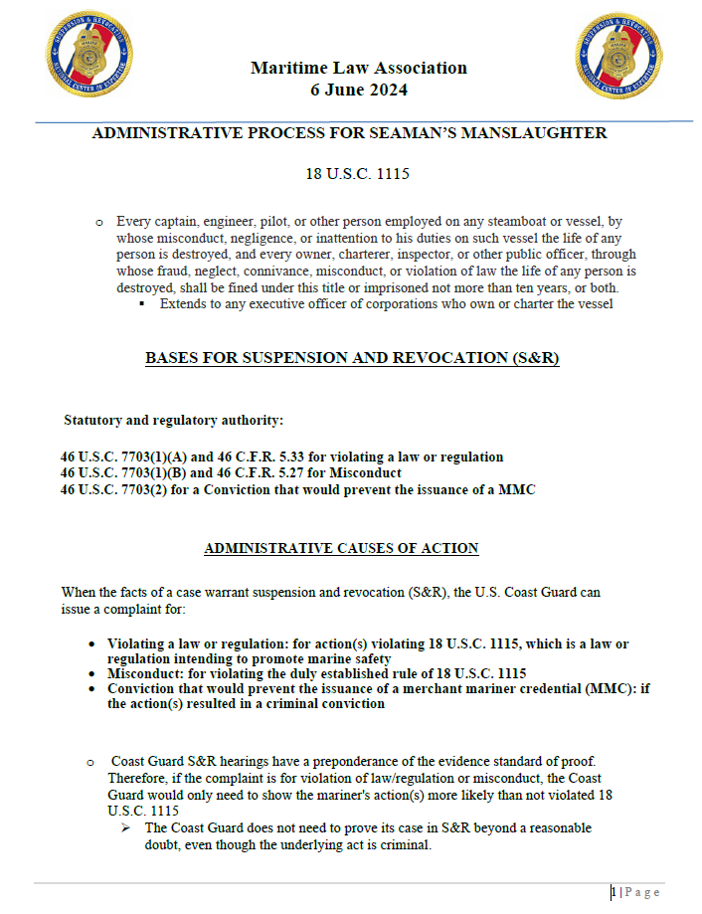

Suspension & Revocation (S&R) Hearing Procedures
This document is an effort to provide a general overview of the procedures used by Administrative Law Judges in suspension and revocation hearings. This information is intended solely for general purposes and should not be considered a substitute for the advice of an attorney.
- Suspension and Revocation (S&R) hearings are administrative proceedings before an Administrative Law Judge (ALJ) concerning a Merchant Mariner's Credential, License(s) or Document(s) and the right to hold those documents and serve under them. These proceedings ONLY affect a Merchant Mariner’s Credential, License(s) or Document(s) - there is absolutely no criminal aspect to these proceedings, nor are jail sentences or criminal fines imposed.
- Because these proceedings are administrative, the Government (Coast Guard) does not provide an attorney or representation for Mariners. Mariners do, however, have several options in regard to representation at a hearing. A mariner may obtain an attorney at his or her own expense, seek to obtain a attorney through local clinics/services, choose to have some other non-attorney assist, or choose to represent his or herself.
- S&R cases begin when a Coast Guard Investigating Officer (IO) files a complaint with the ALJ Docketing Center. This complaint lists the violation(s) allegedly committed by the mariner (also known at this point as the respondent), the IO’s findings of fact, and the IO’s proposed sanction.
- After receiving a complaint, the mariner must submit an answer to the complaint with the ALJ Docketing Center within twenty (20) days. The answer must state whether the mariner agrees or disagrees with the facts, allegations, and proposed sanctions asserted in the complaint.
- Once a complaint is filed and docketed, an ALJ is assigned to the S&R case.
- The ALJ is an independent judicial officer who reviews all filings, schedules and conducts hearings as required, and issues decisions and/or orders regarding the charges in the complaint.
- In S&R proceedings, the burden of proof is on the IO to establish the allegations in the complaint by a preponderance of the evidence. In other words, the IO must establish that the allegations are more likely than not to have occurred. Once a hearing has concluded, the ALJ has the authority to enter an appropriate finding and issue an order after carefully reviewing the evidence that has been presented by both parties.
- The complaint served on the mariner does not in and of itself constitute proof of anything. The complaint is merely a statement of the IO’s position. The IO must prove the allegations in the complaint to prevail.
- Before a hearing, the IO and the mariner are required to exchange witness and exhibit lists to provide notice of what evidence the other intends to present at the hearing.
- At the hearing, the ALJ addresses any questions on whether evidence should or should not be admitted for consideration. The rules governing the procedures to be followed by the parties are contained in Title 33 CFR Part 20 and 46 CFR Part 5.
- The IOs present their evidence first because they bear the burden of proof. After the IO presents the Coast Guard’s case, the mariner may make motions or arguments as to whether or not the IO has proven his or her case.
- The mariner then has the opportunity to also present evidence. Once the mariner presents evidence (if any), the IO may rebut in response to any new matters raised by the mariner’s evidence.
- After all of the evidence is presented, the ALJ may allow the parties to make closing arguments summarizing their views of the case. Arguments are not evidence.
- At the end of the hearing, the ALJ will ask the parties whether they want to present written briefs, including proposed findings of fact and conclusions of law. If either of the parties wants to submit these matters in writing, the ALJ will provide a schedule for making the written submission.
- If both parties waive submitting written briefs and request a decision from the bench, the ALJ may make an oral decision on the record at the close of the hearing followed by a short written decision summarizing the decision stated on the record.
- Should the IO fail to meet the burden of proof, the ALJ will dismiss the complaint. A dismissal means that the mariner would leave the proceedings with his or her credential, license(s) and/or document(s).
- Once a decision is issued by the ALJ, the parties are given notice and information that explains how to appeal the decision if they disagree with it. There is a time limit of 30 days or less to appeal.
- More detailed information and specific requirements for S&R proceedings are contained in the federal regulations. The regulations for S&R hearings in 33 CFR Part 20 and 46 CFR Part 5 may be viewed from a Government website (http://ecfr.gpoaccess.gov).
- Additional information may also be found in the frequently asked questions (FAQs) which are also provided on this web site.

APPENDIX I

See separate PDF file.

APPENDIX II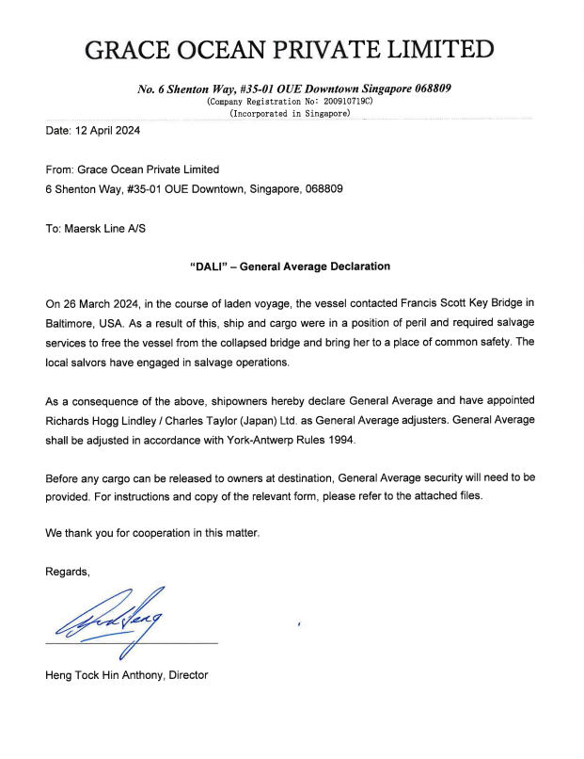

APPENDIX III
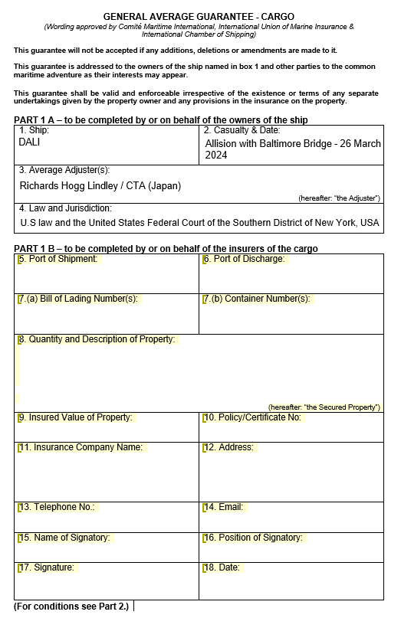

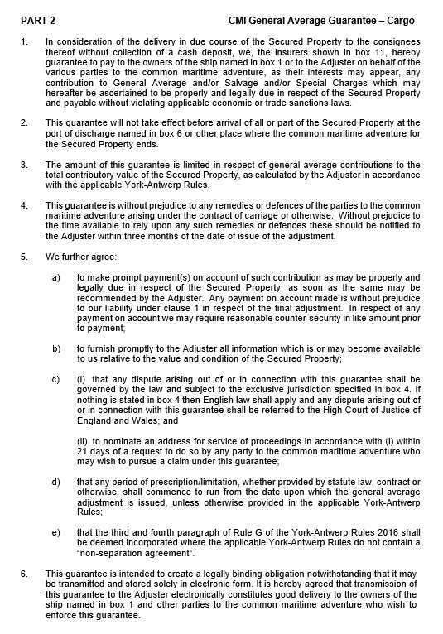

APPENDIX IV
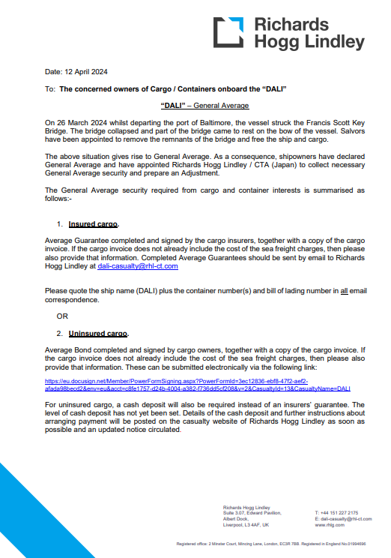
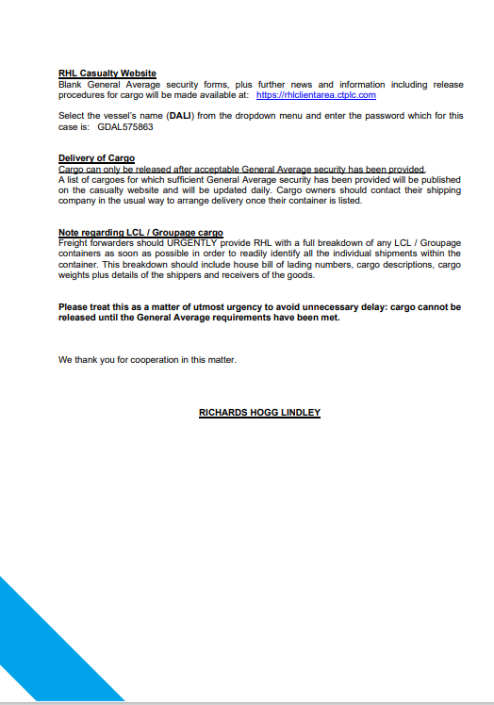

Contact of Containership Dali with the Francis Scott Key Bridge and Subsequent Bridge Collapse, Marine Investigation Preliminary Report, National Transportation Safety Board, May 14, 2024, available at https://www.ntsb.gov/investigations/Pages/DCA24MM031.aspx.
In the Matter of the Petition of Grace Ocean Private Limited, as owner of the M/V Dali, and Synergy Marine Pte Ltd, as Manager of the M/V Dali, for Exoneration from or Limitation of Liability, United States District Court, District of Maryland, Northern Division, Case 1:24-cv-00941.
Id. “Claim by Mayor and City Council of Baltimore Pursuant to Supplemental Federal Rule F(5) In Relation to the Key Bridge Allision.
Cited to in Matter of Majestic Blue Fisheries, LLC, 2014 WL 3728556 (D.Guam 2014).
Declined to follow by Estate of Lewis, 683 F.Supp. 217, (N.D.Cal. 1987); Distinguished by Complaint of Seawise, Inc., 975 F.Supp 1466 (M.D.Fla. 1997); cited to authoritatively in Matter of Denver, 2024 WL 1075144 (D.Mass 2024) and Castillo v. Guardian Insurance Company, Inc. 2024 WL 310641 (D.P.R. 2024); examined thoroughly by Dalton v. Unknown Claimants, 2021 WL 2815224 (M.D.Fla. 2021).
Distinguished by Complaint of Seawise, Inc., 975 F.Supp 1466 (M.D.Fla. 1997); followed with reservations by Complaint of Dillahey, 733 F.Supp. 874, D.N.J.
Cited by In re Parish of Plaquenmines, 231 F.Supp.2d 506, 513, (E.D.La. 2002), In re Hanke, 1980 WL 6688532 (D.Or. 1980).
Examined thoroughly by In re Omega Protein, Inc., 548 F.3d 361 (5th Cir. 2008); Cited to by In re Hedron Holdings, LLC, 2023 WL 6382609 (E.D.La. 2023), Matter of Jack’d Up Charters LLC, 681 F.Supp.3d 560, 567, (E.D.La. 2023), Matter of Cheramie Marine, L.L.C., 2023 WL 4295710 (E.D.La. 2023); and Matter of Diamond B. Industries, LLC, 663 F.Supp.3d 582, 592 (E.D.La. 2023).
Declined to follow, distinguished by, and disagreements recognized by multiple courts on grounds restricted to calculating damages.
Disagreed with, declined to follow, abrogation recognized by, and declined to extend by multiple courts on grounds restricted to matters not relevant to privity and knowledge.
Distinguished by BOPCO, L.P., 2013 WL 4854121 (E.D.La. 2013) and Hillcorp Energy
Discussed by Matter of Wilson Yachts, LLC, 605 F.Supp.3d 695 (D.Md. 2022).
Distinguished by In re Omega Protein, Inc., 548 F.3d 361 (5th Cir. 2008); examined extensively by Matter of Cheramie Marine, L.L.C., 2023 WL 4295710 (E.D.La. 2023); discussed by SCF Waxler Marine, L.L.C. v. Aris T M/V, 24 F.4th 458 (5th Cir. 2022) and Matter of Dredge Big Bear, 525 F.Supp.3d 731 (M.D.La. 2021).
Discussed by Matter of Liquid Waste Technology, LLC, 2024 WL 117022 (D.Conn. 2024), Matter of Energetic Tank, Inc., 607 F.Supp.3d. 328 (S.D.N.Y. 2022), and Matter of Bouchard Transportation Co., Inc., 433 F.Supp.3d 480 (S.D.N.Y. 2019).
Amended judgment and order entered as Moran Towing Corp. v. Young, 597 Fed.Appx. 33 (2nd Cir. 2015); Disccussed by Adams v. Liberty Maritime Corporation, 475 F.Supp.3d 91 (E.D.N.Y. 2020); Cited by Matter of Energetic Tank, Inc., 607 F.Supp.3d 328 (S.D.N.Y. 2022), In re Nagler, 246 F.Supp.3d 648 (E.D.N.Y. 2017).
Declined to extend by In re Complaint of Crosby Tugs, L.L.C., 2005 WL 7873785 (E.D.La. 2005) with respect to analysis of the Penssylvania and Oregon rules.
Distinguished by Hellenic Lines, Ltd. v. Prudential Lines, Inc., 813 F.2d 634, 1987 AMC 2470 (4th Cir. 1987); Cited by Serigne v. Cox Opertaing, L.L.C., 2008 WL 4003117 (E.D.La. 2008).
Distinguished by Great Lakes Inusrance SE v. Anderson, 89 F.4th 212 (1st Cir. 2023); Limitation of holding recognized by In re Omega Protein, Inc., 2007 WL 1974309 (W.D.La. 2007); Cited by Matter of Lasala, 2021 WL 2002503 (E.D.La. 2021).
Distinguished by Petition of Binstock, 213 F.Supp 909 (S.D.N.Y. 1963) and distinguished with extensive analysis in Matheny v. Tennessee Valley Authority, 557 F.3d 311 (6th Cir. 2009); Examined by Maziar v. State, Dept. of Corrections, 216 P.3d 430 (Wash.App.Div.2 2009); Cited by Matter of Diamond B. Industries, LLC, 663 F.Supp3d 582 (E.D.La. 2023).
Declined to follow by Complaint of Martin, 18 F.Supp.2d 126 (D.Mass. 1998) and Hercules Carriers, Inc. v. Claimant State of Fla., Dept. of Transp., 768 F.d 1558 (11th Cir. 1985); Discussed by In re Hilcorp Energy Company, 2023 WL 8558078 (E.D.La. 2023); Cited by Matter of Deep South Airboats, LLC, 2023 WL 5000887 (E.D.La. 2023) and Skanska USA Civil Southeast Inc. v. Bagelheads, Inc., 75 F.4th 1290 (11th Cir.).
Discussed by In re Bridge Const. Services of Florida, Inc., 39 F.Supp.3d 373 (S.D.N.Y. 2014); Cited to by Matter of D’Onofrio General Contractor Corp., 431 F.Supp.3d 95, 2019 AMC 653 (E.D.N.Y. 2019).
Distinguished by Petition of Kristie Leigh Enterprises, Inc., 72 F3d 479, 1996 AMC 697 (5th Cir. 1996); Cited to by Matter of Chavez, 2024 WL 718017 (S.D.Fla. 2024).
Distinguished by In re Complaint of Sea Wolf Marine Towing and Transp., Inc., 2007 WL 3340931 (S.D.N.Y. 2007).
Distinguished by In re Complaint of Sea Wolf Marine Towing and Transp., Inc., 2007 WL 3340931 (S.D.N.Y. 2007) and Matter of Wilson Yachts, LLC, 605 F.Supp.3d 695 (D.Md. 2022).
Cited by In re M/V MSC Flaminia, 72 F.4th 430 (2nd Cir. 2023).
Distinguished by Crowley Marine Services, Inc. v. Maritrans, Inc., 530 F.3d 1169 (9th Cir. 2008) on unrelated grounds (apportionment of fault).
Distinguished by Peter Paul, Inc. v. Rederi A/B Pulp, 258 F.2d 901, 1958 AMC 2377 (2nd Cir. 1958); Cited to by In re United States in a Cause for Exoneration from or Limitation of Liability with Respect to DHS-CBP Vessel M382901 (M901), 331 F.Supp.3d 1112 (S.D.Cal. 2018), discussed extensively by Matter of Majestic Blue Fisheries, LLC, 2014 WL 378556 (D.Guam 2014).
Distinguished by In re BOPCO, L.P., 2013 WL 4854121 (E.D.La. 2013).
The Star of Hope, 76 U.S. 203, 19 L. Ed. 638 (1869); McLoon's Adm'r v. Cummings, 73 Pa. 98, 98 (1873); McAndrews v. Thatcher, 70 U.S. 347, 18 L. Ed. 155 (1865); Cia. Atlantica Pacifica, S. A. v. Humble Oil & Ref. Co., 274 F. Supp. 884, 891 (D. Md. 1967).
Royal Ins. Co. of Am. v. Cineraria Shipping Co., 894 F. Supp. 1557, 1559-60 (M.D. Fla. 1995) (cleaned up).
Orient Mid-E. Lines, Inc. v. Shipment of Rice on Bd. S.S. Orient Transporter, 496 F.2d 1032, 1034–35 (5th Cir. 1974) (footnotes omitted)
Ralli v. Troop, 157 U.S. 386, 15 S. Ct. 657, 39 L. Ed. 742 (1895)
Orient Mid-E. Lines, Inc. v. Shipment of Rice on Bd. S.S. Orient Transporter, 496 F.2d 1032, 1034–35 (5th Cir. 1974)
Hicks v Palington (1590); Masefield AG v. Amlin Corporate Member Ltd. (the “Bunga Melati Dua”) [2011] EWCA Civ 24; Herculito Mar. Ltd. v. Gunvor Int’l BV (the “Polar”) [2021] EWCA 3318 (Comm).
Cia. Atlantica Pacifica, S. A. v. Humble Oil & Ref. Co., 274 F. Supp. 884, 898 (D. Md. 1967)
Columbian Ins. Co. of Alexandria v. Ashby & Stribling, 38 U.S. 331, 338–39, 10 L. Ed. 186 (1839); See also Am. Afr. Exp. Co. v. S.S. Exp. Champion, 442 F. Supp. 715, 717–18 (S.D.N.Y. 1977)
Am. Afr. Exp. Co. v. S.S. Exp. Champion, 442 F. Supp. 715 (S.D.N.Y. 1977)
York-Antwerp Rules 2016, Available here: https://comitemaritime.org/wp-content/uploads/2018/06/2016-York-Antwerp-Rules-with-Rule-XVII-correction.pdf
See Gilmore & Black, supra note 14, § 5-13, at 266. See also Flint v. Christall (The Irrawaddy), 171 U.S. 187 (1898).
Royal Ins. Co. of Am. v. Cineraria Shipping Co., 894 F. Supp. 1557 (M.D. Fla. 1995); Cal. & Hawaiian Sugar Co. v. Columbia S.S. Co., 391 F. Supp. 894 (E.D. La. 1972), aff’d, 510 F.2d 542 (5th Cir. 1975). The term “Jason clause” comes from The Jason, 225 U.S. 32 (1912), which was the name of the ship that was the inspiration for the clause.
Deutsche Shell Tanker Gesellschaft mbH v. Placid Ref. Co., 993 F.2d 466, 468 (5th Cir. 1993)
National Transportation Safety Board Preliminary Report, Available at: https://www.ntsb.gov/investigations/Documents/DCA24MM031_PreliminaryReport%203.pdf
United States v. Nobles, 422 U.S. 225 (1975).
However in many European/civil law countries, in-house counsel are not “members of the bar” such that statutory privilege applies to them.
Mangouras v. Boggs, 980 F.3d 88 (2d Cir. 2020).
Upjohn Co. v. United States, 449 U.S. 383, 392 (1981).
46 U.S.C. § 40101 et. seq.
https://www.fmc.gov/industry-advisory-all-fmc-statutes-regulations-remain-in-full-effect-following-bridge-collapse/.
https://www.fmc.gov/fmc-announces-hearing-on-shipping-conditions-in-the-red-sea/.
According to public filings in the FMC’s docket, from October 13, 2023 to January 10, 2024, 9 carriers filed such Special Permission Applications relating to the Red Sea crisis, including Zim American Integrated Shipping Services, Turkon Container Transportation & Shipping, CMA CGM, Hapag Lloyd, Mediterranean Shipping Company, Maersk, Ocean Network Express, American President Lines, and Vanguard Logistics Services.
Examples include Federal Maritime Commission Docket No. SP-011961, Docket No. SP-011959, and Docket No. SP-011965.
https://www.fmc.gov/fmc-announces-hearing-on-shipping-conditions-in-the-red-sea-2/; See also FMC Docket No. FMC-2024-0003.
https://www.fmc.gov/fmc-releases-schedule-for-hearing-on-threats-to-shipping/.
US v. McKee, 68 F.4th 1100, May 30, 2023.
https://www.kcur.org/news/2022-04-13/missouri-attorney-general-refiles-criminal-charges-in-branson-duck-boat-tragedy-that-killed-17
As published by the U.S. Coast Guard and available on their website at https://www.uscg.mil/Resources/Administrative-Law-Judges/General-Suspension-and-Revocation-Information/General-Information/.

