INLAND WATERS AND TOWING COMMITTEE
MEETING AGENDA – THURSDAY, OCT. 27, 2:00-3:00 PM
At the offices of Liskow & Lewis, LLP
One Shell Square, Suite 5000
701 Poydras Street
New Orleans LA 70139

Dial In Number: (605) 562-0020
Enter Access Code: 130-270-697
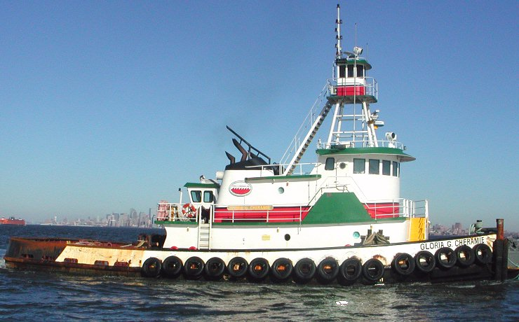
- BRIEF INTRODUCTION. Committee Chair, Kent Roberts.

- MAIN PANEL PROGRAM:

Subchapter M: It’s Finally Here - Now What Do We Do (and What Should Lawyers be Worried About): A Panel from the Perspectives of the Coast Guard, Industry, and a Lawyer

- CAPT Shannon Gilreath. Chief, Coast Guard Office of Maritime and International Law. Open issues in implementation and incentivizing the TSMS option over the Coast Guard option; changes and Coast Guard expectations in casualty investigations.

- Rene Cheramie, President, A.R. Cheramie Marine Management, Inc.
A look at their ISM based SMS & compliance with SubM for a TSMS; compliance timeline operators need to be aware of; industry’s thoughts on how SubM will affect casualty investigations; issues of attorney client privilege in casualty investigation, and other industry concerns.

- Barrett Rice, Maritime Attorney, Jones Walker, New Orleans
Statutory fault/neg per se issues; how SubM intersects with the Pennsylvania Rule; conducting casualty investigations to comply with SubM and attempting to preserve privilege

- Other Business

Respectfully,

C. Kent Roberts,
Chair

We have applied for CLE credit in LA. Three Powerpoint presentations are available on our committee page.

