GREGORY R. SINGER, Esq.

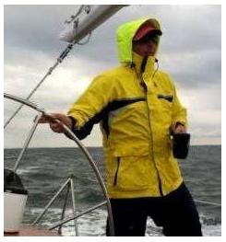
Mr. Singer graduated Cum Laude from the William & Mary School of Law, where he was an accomplished member of the Moot Court and Alternative Dispute Resolution (ADR) teams, as well as the Bill of Rights Journal. Prior to joining Lochner Law Firm, he served in the United States Coast Guard's Judge Advocate General's office in Boston, Massachusetts. Mr. Singer is a member of Maryland State Bar and the United States District Court for the District of Maryland, was named a Superlawyers Rising Star for 2018, is an associate of the Maritime Law Association of the United States, and a founding member of the Rising Maritime Attorneys of the Chesapeake (R-MAC).
Mr. Singer is a longtime Annapolitan and a lifelong sailor. Prior to his legal practice he worked for seven years on historic sail-training ships, charter vessels, and private yachts in the Caribbean. He holds a 100-ton Coast Guard Master’s license with sail and tow endorsements, and is a member of the Chesapeake Area Professional Captain’s Association. When he is not serving his clients' legal needs, Mr. Singer maintains an active sailboat racing and offshore delivery schedule. His recent accolades include first place at the 2015 Annapolis National Offshore One-Design Championships, and the prestigious City of Annapolis perpetual trophy in 2017.

