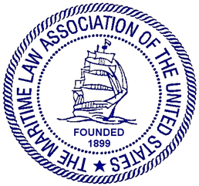

STEVEDORES, MARINE TERMINALS,
AND VESSEL SERVICES COMMITTEE

Thursday, October 31, 2019, 1:30 – 3:30 p.m.
Hyatt Regency Scottsdale Resort & Spa at Gainey Ranch
Scottsdale, Arizona

AGENDA

I. Welcome and Speaker Introductions
Deborah C. Waters, Waters Law Firm, Norfolk, Virginia (10 Minutes)
1:30-1:40

II. Legal Responsibilities Marine Terminals Owe to Visiting Vessels
David H. Sump, Willcox & Savage, Norfolk, Virginia (1 Hour CLE)
1:40 – 2:40

III. Longshoremen’s and Harbor Workers’ Compensation Act:
Update of Case Law, Regulation and Legislation
Discussion of Selected Cases
Kenneth G. Engerrand, Brown Sims, Houston, Texas ( .5 Hour CLE)
2:40 – 3:10

IV. Old Business
A. FMC Interpretive Rule on Demurrage and Detention
B. U.S. State Department ACPIL Teleconference
C. Future CLE topics
D. Future Committee projects
3:10 – 3:30

V. New Business

VI. Adjournment

