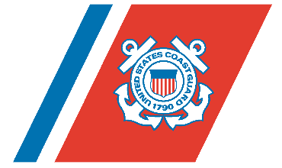
U.S. Department of Homeland Security

United States Coast Guard

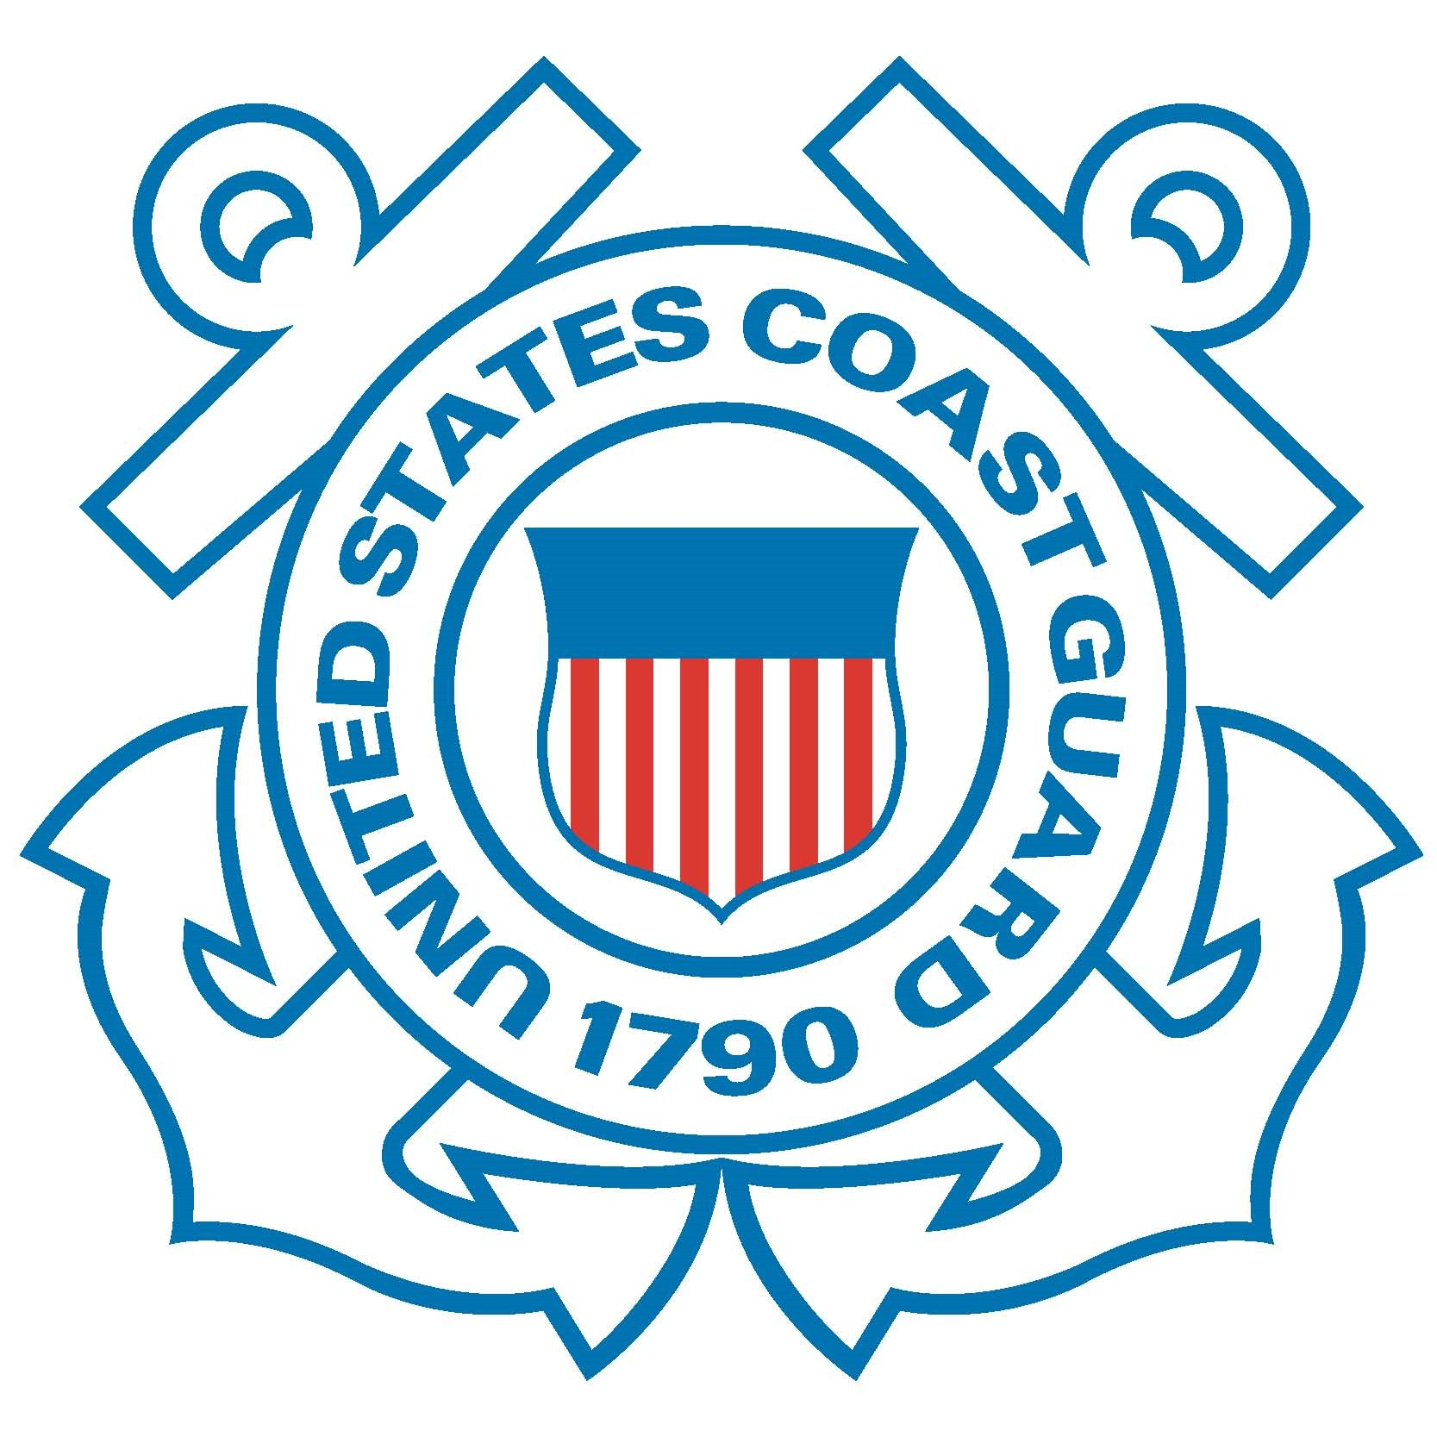

Captain Jason D. Neubauer

Chief, Office of Investigations & Analysis
U.S. Coast Guard

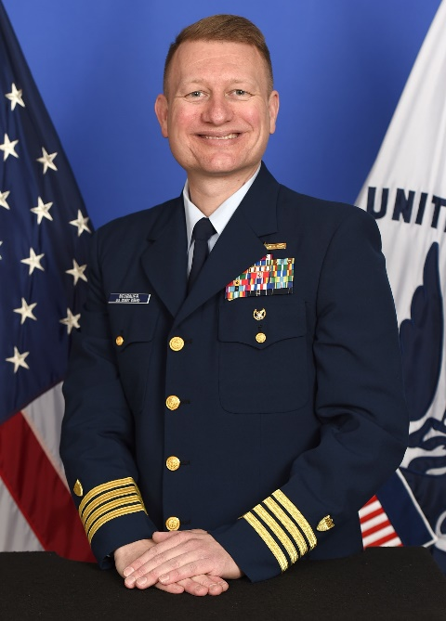
Captain Neubauer is currently serving as the Chief of the Office of Investigations & Analysis at Coast Guard Headquarters. He is responsible for overseeing marine casualty investigations, suspension & revocation cases involving credentialed mariners, violation investigations, and data analysis for the Coast Guard’s Prevention operations. From October 2015 to October 2017, he also served as the Chairman of the Commandant’s Marine Board of Investigation into the sinking of the Steam Ship EL FARO.

Captain Neubauer previously served as the Commanding Officer of Marine Safety Unit Chicago from July 2012 to
July 2014 where he was responsible for Prevention operations spanning 300 miles of Lake Michigan coast line and 180 miles of the Illinois River and its tributaries. He also served as the Prevention Department Chief and Deputy Commander at Coast Guard Sector Honolulu from July 2008 to June 2012, where he was responsible for overseeing Coast Guard
operations throughout a 1.5 million square mile Captain of the Port
Zone that includes the entire Hawaiian Islands Chain and American Samoa.

Captain Neubauer was commissioned as an Ensign after graduating from the United States Coast Guard Academy in 1992 with a Bachelor of Science Degree in Marine Engineering and Naval Architecture.
After completing an initial marine inspection training tour in Seattle, Washington, he transferred to the Gulf of Mexico for a four year stint at Marine Safety Office Morgan City from 1996-2000. While in Morgan City, he completed inspections on vessels supporting the offshore drilling industry and served for three years as the unit’s Senior Investigating Officer, investigating a wide variety of marine casualties.

After Morgan City, Captain Neubauer transferred north to the head of the Mississippi
River and served as the Supervisor of Marine Safety Detachment St Paul, Minnesota from August 2000 until June 2003. During his time in St Paul, he worked closely with the Army Corps of Engineers and became well acquainted with the tug and barge industries that transport vital commerce on the Western Rivers.

