Biographical Summary
David B. Sharpe

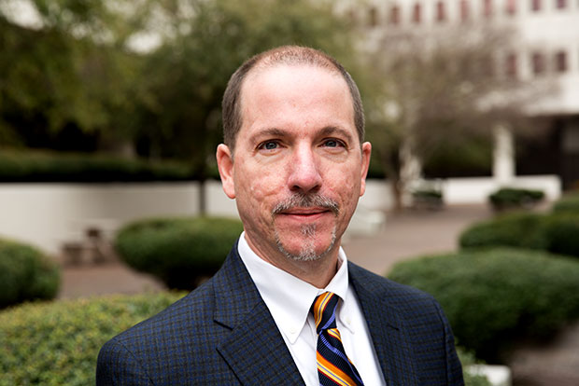

David B. Sharpe is a New Orleans-based maritime attorney and educator whose law practice is focused upon risk management in the marine-transportation and energy-service markets. Since 1990, David has represented vessel interests, their insurers, and oilfield-service companies who work both onshore and offshore. David helps his clients understand and manage their risks in the oilfield and alternative-energy markets in the Gulf of Mexico and beyond.

David’s work includes negotiating, interpreting, and litigating service contracts, charterparties, and marine-insurance policies. David is widely published, and he has lectured about maritime risk management in the US, UK, Norway, Singapore, and India. David is an editor of Cases & Materials on Admiralty (West Academic 6th ed. 2017), a leading law-school casebook on admiralty and maritime law. David is also an adjunct professor at Tulane Law School, where since 1996 he has taught an upper-level class currently called “Towage & Offshore Services.”

David holds a degree in electrical-engineering from Tulane University (BSEE 1985). Before getting his law degree from George Washington University Law School (JD 1990, with honors), he worked for several years as a systems engineer for Motorola in Houston. David’s background in engineering has informed his recent work related to autonomous and remote-controlled vessels and port operations.

David is a shareholder in the law firm Lugenbuhl, Wheaton, Peck, Rankin & Hubbard, which has offices in New Orleans, Baton Rouge, Houston, and Gulfport. David and his wife, Eleanor, have three children.

