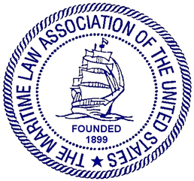

MARITIME LAW ASSOCIATION OF THE UNITED STATES

CARRIAGE OF GOODS COMMITTEE

MEETING ANNOUNCEMENT AND CLE WEBINAR WITH TIMED AGENDA

Wednesday, May 5, 2021--- 12:30 p.m. to 2:00 p.m. EDT

Welcoming Remarks and Speaker Introductions (12:30 – 12:35 p.m.)
Dennis A. Cammarano, Long Beach, California
Chair, Carriage of Goods Committee

Update on the Rotterdam Rules (12:35 – 12:45 p.m.)
Speaker: Professor Michael F. Sturley
University of Texas, Austin School of Law

CLE Presentation

Sanitary Transportation of Human and Animal Food (12:45 - 1:45 p.m.)
Presenter: Patrick Brecht, PhD
PEB Commodities, Inc.

Moderator: Dennis A. Cammarano

Discussion/Questions (1:45- 1:55pm)

New Matters/Introduction of Incoming Committee Leads (1:55-2:00pm)

The Maritime Law Association of the United States (“MLA”) is an accredited New York provider of continuing legal education (“CLE”). The program will be appropriate for experienced and newly admitted attorneys (Non-Transitional and Transitional). 1.0 New York CLE credit in Areas of Professional Practice will be offered.

This program has been approved by the Pennsylvania Continuing Legal Education Board for 1.0 hours of substantive law, practice and procedure CLE credit and 0.0 hours of ethics, professionalism, or substance abuse CLE credit.

